Introduction
Thank you for taking the time to learn about this important subject. Whether you have already experienced health effects or you are part of the leading wave of people waking up to the importance of EMF pollution on your health, my intention is to give you a resource that will quickly help you understand what can be done to reduce your exposure to man-made electromagnetic fields.
My journey into this field began five years ago when multiple wireless smart meters were installed directly below my bedroom. Like so many people, I was injured by these devices. Since that time, I have devoted myself to learning as much as I could about this topic. It has been a crash course filled with lessons learned and (many, many) mistakes made. I have written this book so that you can learn in one afternoon what has taken me five years to understand. Hopefully this will greatly accelerate your learning curve so that you can improve the health of you and your family.
The primary purpose of this book is to help you find and create a healthy home in your community. I realize that many people who are affected by EMF pollution now live off-grid in more natural settings. For individuals who have been seriously injured, this is often the only option. However, most moderately affected people need to find ways to be healthy near their families, careers and social networks. In short, they need to be able to have a healthy home in our modern society.
This book will also greatly help families that are not necessarily experiencing effects from EMF pollution, but that want to have a living environment that is as healthy as possible. Just like organic food and chemical-free products were once fringe ideas that are now mainstream, low-EMF homes will someday be commonplace for health conscious people. Many helpful suggestions are provided within this guide to make your current home healthier, as well as low-EMF practices should you be building or remodeling a home. I have also included the fundamentals about electromagnetic fields that will give you a good foundation and the skills you need to measure the various forms of EMF pollution.
The four sections are arranged in the following order. It is best to start from the beginning, but there is nothing wrong in going straight to the section that is most pertinent for you today.
- Section 1: The EMF Basics (To help you build a foundation in electromagnetic fields)
- Section 2: Finding a Low-EMF Home (A step-by-step process to find a healthy home)
- Section 3: Measuring Electromagnetic Fields (The best meters and how to use them)
- Section 4: Creating a Low-EMF Home (Ideas for your current home or a new construction)
If you can use what I have learned to protect your health, and that of your family, then this experience will have been well worth it. I appreciate any feedback you have. Please contact me to share what works best for you or if you have any questions after reading the book. I will be updating this book over the years as our technological society and electromagnetic environment inevitably evolves. Hopefully more and more solutions will become available as awareness grows and EMF pollution gets the attention it deserves.
Jeromy Johnson, October 2016

Section 1
The EMF Basics

Setting the Stage
Buying or renting a home is a huge financial decision. Before making this decision, you want to make sure the electromagnetic environment of the home and the surrounding neighborhood is conducive to good health. This guide will help you successfully navigate this decision and hopefully save you time and money while helping you find and create a healthy home.
I want to acknowledge upfront that this can be a scary, overwhelming subject matter for many people. I believe this is the primary reason why most people do not even want to consider the health effects of electromagnetic fields. By reading this guide, you have already gotten through the most difficult process, which is realizing that this is important for you and your family. Congratulations! And, thank you for taking this journey with me.
Throughout this book, I provide you with a detailed step-by-step process to find a home with low-EMF pollution and a process to make your current home healthier. It may seem complicated at first, but realize that it gets easier once you understand the basics. I have walked many people through this process and now they have healthy homes in communities where they enjoy living.
This process has also worked for my wife and me. We have found incredible homes to live in that have become healing for us. We have discovered the elements that need to be in place for a home to be healthy. This is vital should you or someone in your family already be electrically sensitive and for anyone who wants to prevent health issues related to EMFs. I summarize the core elements of this guide later on in the section called “Your Ideal Home”. It is my sincere hope that our experience will help you find and create a home that is truly healthy for your family.

A cabin in the mountains is not your only option for a low-EMF home.
Why I created this guide
Several people asked me to create this guide to help them (and you) navigate this complicated realm. When I became electrically sensitive in 2011, finding a safe place to live became incredibly difficult for my wife and I. Granted, it has not been all bad. Our lives the past few years have been filled with travel and adventure. Because of this, I have gained extensive experience measuring homes for safe levels of EMFs. I have measured and found healthy homes throughout Europe, Indonesia and the United States.
Most people look at our lives in amazement. What many do not realize, however, is what we have gone through to be in homes where we can actually sleep and live symptom free. It has been a journey of discovery through trial and error that has not been easy. My hope is that our experience will make it much easier for you to create your own EMF sanctuary in your community.
During the past five years, I have become quite experienced in knowing what to look for in a home when it comes to the electromagnetics. I also have the sensitivity to quickly feel when a home is not right. My measurement devices and engineering background have combined with my sensitivity (some would call it a sixth sense) to help us find and create safe places to live. I have found that when certain conditions are met, a home can be a very healing place. I know what this looks and feels like and I have measured and personally experienced over 100 homes the past five years to learn what it takes. This guide will give you what I have experienced, along with what my mentors have taught me, to help you live in a home that is healthy for you and your family.

Who is this guide for?
The short answer is that everyone is affected by electromagnetic field (EMF) pollution. Electromagnetism is life. At the deepest level of biology, your energy is based on how many electrons your mitochondria receive through food, water and the environment. This electron transfer can be disrupted by artificial EMF pollution, which leads to a cascading sequence of biological dysfunction.
A current majority of people cannot feel the immediate effects of artificial electromagnetic fields. It is estimated that between 3% and 10% of the population has the ability to sense EMFs consciously and the rest of the population experience them after decades of exposure as the development of modern (chronic) health issues and diseases. Many people are unaware of the EMF factor and dismiss it or even go so far as to call those who can sense artificial electromagnetic fields as “crazy” or “tin-foil-hat people.” However, other people’s ignorance does not need to affect the health and safety of you and your family.
This issue is a controversial hot spot with more and more data accumulating showing the biological effects of artificial EMFs. At the same time, wireless technology is becoming an even greater factor in our economy. Because of this, the safety of man-made electromagnetic fields is becoming a leading edge of the health movement and is re-shaping how we understand our environment. The most intelligent and forward-thinking people on the planet are now paying close attention to this issue, right along with you.
In particular, there are certain people that I highly encourage to pay close attention to EMF pollution when it comes to their home. This is because electromagnetic fields will typically affect them more than the general population. They include:
- Families with small children – babies and young children are most affected by EMFs.
- Couples that want to get pregnant – this can be very difficult in a high-EMF environment.
- Any family with an autistic child - these children do much better in a low-EMF environment.
- People with Lyme, thyroid conditions, autoimmune issues or heavy metals in their body.
- Anyone who has had reactions to chemicals (MCS) or mold in their life.
- Those who are already electrically sensitive (ES) or electro-hypersensitive (EHS).
- Anyone who wants to avoid becoming electrically sensitive because of a toxic home.
- People who have food allergies or who are more sensitive to their environment.
- Those who have a history of depression or anxiety. EMFs can make these worse.
- Healthy individuals who want to lead long, healthy lives. Research points to a link between EMF pollution and cancer, immune and endocrine system dysfunction and neurological conditions, such as dementia and Alzheimer’s disease. Why spend 30 years (or even a few years) in a home that may diminish your health in the long-term?

Who this guide is not for
I would be remiss in stating that this guide is for everyone who is electro-hypersensitive (EHS). The fact of the matter is that a small percentage of people are so severely EHS / MCS (multiple chemical sensitivity) that the recommendations and techniques in this guide are simply not adequate. The EMF knowledge and background provided will benefit you, as will many of the ideas and methods found within. However, this guide is ultimately meant for families that want to have a healthier home and for moderately electrically sensitive people who can still function in relatively populated areas. My purpose is to prevent even more people from becoming severely electrically sensitive. If you take action soon after realizing you are affected by EMFs, then the odds are much greater that you will recover fully or at least not progress toward severe EHS.
If you are already severely EHS/MCS, please contact me through my website (www.emfanalysis.com) or have someone contact me for you. I will provide you with information from engineers who have spent decades learning how to build off-grid, ultra-low-EMF homes. There are techniques that will help you and your builder. However, except for the suggestions and resources in Appendix B, extremely low-EMF building techniques and the remediation of high-EMF homes are beyond the scope of this guide. There is a way forward for you, but I encourage you to get the very best information possible before starting any project so that you don’t waste your savings and time pursuing false solutions. Unfortunately, there are currently very few EMF consultants in the world who are truly qualified to help severely EHS / MCS disabled individuals, so please do your research before moving into a home or area that may not meet your needs.
Why Only Focus on EMFs?
You may be wondering why I focus on electromagnetic fields without mentioning chemicals, pesticides, herbicides, mold, heavy metals, fluoride, air quality and other toxins within a home that can affect your health? I am in no way downplaying the effect that these pollutants can have on our health (I have experienced their effects first hand and they all can work synergistically with EMFs). However, I want this guide to focus completely on EMFs because I know of few resources that focus only on finding or creating an electrically healthy home. I also do this because EMF exposure is usually one of the most important factors in your long-term health and the hardest to remedy after the fact (especially if the pollution source is not on your property or incredibly expensive to remedy).
There are many books and resources available to help you reduce your exposure to these other toxins in your home. And, obviously, if you smell mold or chemicals, notice a conventional farm down the road that will spray glyphosate or just don’t feel well after visiting a home, don’t go back! I encourage you to learn strategies to reduce your in-home toxin exposures. Beth Greer’s book “Super Natural Home” ¹ is a good place to start.

Common EMF Symptoms
A German medical doctor by the name of Dr. Erwin Schliephake ² first published an article in 1932 noting that his patients were reacting to a military radar tower that had been installed nearby. Since that time, the condition of electromagnetic sensitivity (ES) or electro-hypersensitivity (EHS) has become a global phenomenon. The Swedish and Spanish governments officially recognize the condition as a “functional disability”, similar to being blind or in a wheelchair. It should be noted that Sweden was one of the first countries to implement cell phone technology and there are now approximately 250,000 Swedes who are electrically sensitive. Other countries such as France, Norway, Austria, Canada and the United States are moving toward recognizing this condition as well. France recently granted disability income ³ to an electrically sensitive woman and the EMF working group of the Austrian Medical Association has guidelines ⁴ to help physicians treat electrically sensitive people. The European Academy of Environmental Medicine also recently announced their guidelines ⁵ for the prevention, diagnosis and treatment of EMF related illness. It appears that there is movement within the medical community to recognize this problem. This will be critical as medical experts I speak with expect an increasing tide of affected people the next 5-10 years as the rollout of wireless technology explodes.
Research points to 3-5% of the global population currently being moderately affected by EMFs and this appears to be growing quickly. Nearly 30% of the population is slightly affected (usually without knowing the reason for their symptoms) and may experience one or more of the following symptoms when exposed. At this time, less than 1% of the population is severely affected. As I mention above, this can be an extremely debilitating condition. It is important to point out that all people are affected by EMFs, but only some individuals experience immediate signs of injury.
Here are the most common signs of EMF injury that are discussed in published literature:
- Headaches (tension or pressure on sides of head/temples)
- Insomnia/Sleep Disturbance
- Tinnitus
- Cognitive Impairment/Brain Fog (during and directly after exposure)
- Heart Arrhythmia/Palpitations
- Fatigue
- Skin Rashes (particularly redness and/or burning sensation on face/arms)
- Vertigo/Nausea
- Inner Tension/Agitation/Restless Leg
- Depression/Mood Disturbances
A simple way to test if you are affected by electromagnetic fields is to visit a low EMF environment (such as real, off-grid, nature) for a period of time. Typically, within 24-72 hours of being in a clean environment, your symptoms will begin to diminish and possibly vanish. My symptoms are often gone within 24 to 48 hours of sleeping in a forest far from cell towers. It’s like a switch is flipped and my sleep becomes deep and my mental clarity and energy returns. Severely affected people may take longer - up to a few weeks. Unfortunately, the symptoms typically reappear upon coming back into a high-EMF environment. However, the more time you spend in a good environment, the stronger your body will become. People who live in low EMF homes typically see their level of sensitivity decline and their health improve. That is why I created this guide.
Another good test is to see how you feel when the power goes out after a storm. Most electrically sensitive people feel great! I learned this in 2012 when we rented a home in Bali far away from any cell towers or wireless technology in a protected valley, yet I still didn’t feel healthy. Then, one evening the electricity in our village went out after an intense Bali thunderstorm and I finally slept deeply and awoke feeling amazing. After that night, we kept off most of the circuits in our home, my wife got used to turning on lights that didn’t work and my health continued to improve.
You can learn more about the health effects and receive a guide to help reduce your symptoms on my website: www.emfanalysis.com/health-effects/ ⁶

Are Pets Affected Too?
The short answer is that of course they are. All life is electromagnetic and I would argue that our pets are more affected by EMFs than us humans. There are recently published studies showing that rabbits can experience heart arrhythmia and high blood pressure when exposed to WiFi. You can read one study here. ⁷ There are also articles ⁸ speaking to the effect that high-RF environments can have on dogs. Anecdotally, I have had numerous people contact me stating that their dogs started acting strangely once wireless smart meters were installed on their home or in their neighborhood. The dogs would act timidly (like they were in pain) and stay away from the part of the home near the smart meter. In some cases, all of the dogs in the neighborhood would bark much more frequently than usual once smart meters were installed. Thus, if you have pets in your family it is important to find and create a safe environment for them to live too.
What exactly are Electromagnetic Fields?
There are four types of artificial electromagnetic fields (EMFs) that are important to consider in your home. Later in this guide I will guide you in measuring each of them.
Magnetic Fields: Magnetic fields occur when there is electrical current running through a wire, metal, appliance or the ground. If we make an analogy with water, it’s like water running through pipes. If the faucet is closed, then there is no water current flowing through the pipes. Typically, if nothing is plugged-in and using electricity, then there should be no electrical current and no magnetic fields. You always need to measure to know for sure though because you can have stray current on water/gas pipes or other metal in your home. Magnetic fields usually occur through simple home wiring errors (such as neutral wires from different circuits being connected) or from a power line outside the home. Depending on the type of electrical distribution system in your area (Delta vs. Wye, which is explained below), you may experience more ground current. Wye served areas have more ground current, which typically creates higher background magnetic fields. I list low-frequency magnetic fields first because they are also likely the most dangerous to biology. Here is a video ⁹ by Karl Riley, an expert in finding and fixing magnetic fields within homes. You will measure magnetic fields with a Gauss meter.
AC Electric Fields: These fields are created by voltage within 50 or 60 Hz AC (alternating current) electrical wiring. To keep with the water analogy, voltage is like the water pressure in pipes. The higher the water pressure, the more force the water will have when it comes out. The higher the voltage, the higher the electric fields. 60 Hz AC Electric fields can typically (though not always) be alleviated by turning off the circuit breakers to a part of the home (no more electrical force available) and by using shielded electrical wiring (EMT conduit with compression fittings or MC cable rather than the standard Romex). It is very important for people to sleep in environments with low electric fields (sleep is typically diminished by high electric fields). I outline the safe levels later in this guide. You can identify the 60 Hz electric fields in your home electrical system using body voltage method or with a digital AC electric field meter. Higher frequency electric fields (see the EMI section directly below) can most readily be identified with a carefully selected AM radio, EMI meter or spectrum analyzer. I will explain how to measure these later in the book. A special note about circuit breakers can be seen in Appendix B, Item #6 regarding the risks of constantly turning circuit breakers on and off. Please read this if you turn off your breakers.
Microwave Radiation / RF (Radio-Frequency Radiation): All modern wireless technology now uses pulse-modulated microwave radiation (also known as radio-frequency radiation – RF). Unlike the analog radio towers that we grew up with, this new digital technology is especially damaging to our biology. We simply do not know all the ways in which the modulated frequencies affect the cells in our body and it could be years until this is fully understood. Common devices that use this type of artificial EMF are smart phones, cell phone towers, cordless phones, Wi-Fi, Bluetooth, iPads, Wi-Fi enabled computers/tablets, wireless baby monitors and wireless smart meters. You will measure microwave radiation with a RF meter.
Electromagnetic Interference (EMI): Dimmer switches, compact fluorescent & LED lightbulbs, solar inverters, powerline arcing, air conditioning and heating systems, and new electronic items with switching mode power supplies (SMPS) create high frequency electric fields on your home wiring. The proper engineering term for this is electromagnetic interference or EMI (this is part of the well-established field of electromagnetic compatibility (EMC) engineering). Some EMF consultants use the term “dirty electricity” for this form of pollution. Powerline “harmonics” is yet another term that is used for this growing EMF problem. These higher-frequency electric fields conduct along the copper wiring in your home (including the neutral/safety ground even when the circuit is turned off) and can then radiate into your living environment. This can create an incoherent and biologically damaging form of electromagnetic radiation in your home. Homes with high amounts of EMI will feel like they have a distinct buzz and the inhabitants often have frequent headaches, fatigue, brain fog, ringing in the ears and poor health in general. You can most easily detect EMI with the Radio Shack AM radio I suggest later. The Alpha Labs Line Noise EMI meter and Gigahertz Solutions digital electric field meter mentioned later are also good meters for this form of EMF pollution. I don’t recommend the Graham-Stetzer meter because of its limited frequency range compared to the Alpha Labs EMI meter.

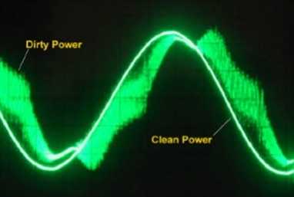
Image credit: The National Foundation for Alternative Medicine
EMI or “dirty electricity” can create serious health effects. Later in this guide you can determine how to measure this. I also encourage you to read my article on EMI ¹⁰ that has solutions and videos to help you remedy this form of pollution.

What are Safe EMF Levels?
Toward the end of this guide I will walk you through the different measurement devices that I recommend should you decide to measure your own home rather than hire an EMF consultant. However, before we get into the process of researching and measuring a prospective home, I want to discuss the readings that you will encounter and what levels are typically considered to be safe.
First, know that government regulations and the safe levels proclaimed by utility and telecommunications companies are not meant to be protective of biology. They are simply meant to make sure the technology works and can grow unimpeded. Due to economic interest, the regulations ignore considerable science and evidence that shows that much lower EMF levels are necessary to have a healthy home.
The reason for this is that government regulations are based on the idea that “if an EMF source does not heat you, then it can’t harm you.” This is a concept that dates back to the 1950’s and 60’s when it was only possible to measure thermal effects. The safety regulations were last updated in 1996 and even that update was based primarily on a document from 1986. Since that time, there have been hundreds of high quality, peer-reviewed, published studies ¹¹ that show biological effects from low-levels of EMF exposure – so called non-thermal effects. One of the most expensive studies ever, the $25 million National Toxicology Program (NTP) cell phone study, released its preliminary results in May 2016. ¹² The researchers found that cell phone radiation does indeed cause cancer and DNA damage in rats. This study is so important that even the American Cancer Society said it marked “a paradigm shift in our understanding of radiation and cancer risk.” Yet, the FCC, which sets the safety guidelines for the United States, and the wireless industry are calling for even greater levels of exposure to power our devices and networks – especially with the planned 5G rollout and autonomous vehicles.
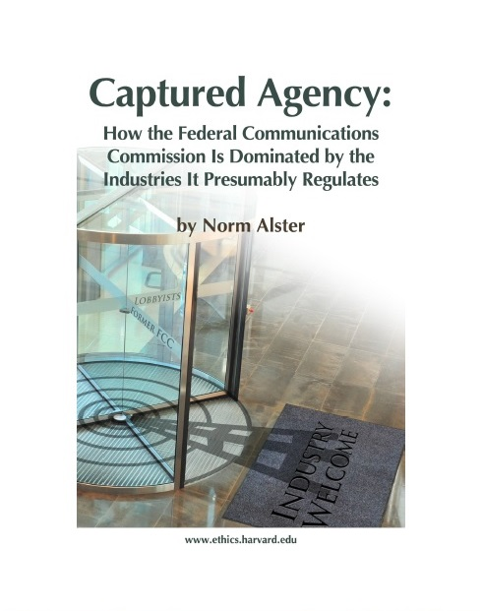
To understand how our official EMF safety guidelines don’t actually protect humanity, I highly recommend reading “Captured Agency”, ¹³ which was published by the Harvard School of Ethics and investigative journalist Norm Alster in 2015. This book lays out how the wireless industry essentially regulates itself by putting its top lobbyists in charge of the FCC. You need to look no further than the current Chairman of the FCC, Thomas Wheeler, who was the chief wireless lobbyist in the United States for twelve years. It should be noted that Norm Alster also wrote about the DotCom Crash and the 2008 Financial Crisis before they happened. That he would now focus on the wireless safety issue is very telling.
This is why it is critically important that you protect yourself and your family now while the political, economic and technological solutions are determined in the coming years and decades. This is the wisest thing we can do at this time and I do believe our society will eventually evolve to acknowledge and remedy this situation – just as we did with DDT, smoking and asbestos.
I am now going to outline two sets of readings for the four types of EMFs – one for a typical healthy family (Typical Safe) and one for a family with someone whose health is compromised in one of the ways I mention above (Sensitive Safe). If you have a family member with Lyme, autism, a neurological condition or who is already electrically sensitive, then you want to pay attention to the lower levels.
Please note that these are general guidelines. You may find that you need even lower EMF levels or that you can handle higher levels. Every person and every family is different, but these are the levels I recommend based on my research, personal experience and work with many different people in this field.

Magnetic Fields:
Typical Safe: 1.0 milliGauss (mG) in living areas of home.
Sensitive Safe: 0.1 mG or below in sleeping area with electrical breakers off.

AC Electric Fields:
Typical Safe: 5.0 V/m with digital meter or 1.0 Volts through body voltage.
Sensitive Safe: Below 1.0 V/m with digital meter or 0.1 Volts through body voltage.

Microwave Radiation (RF):
Typical Safe: Below 10 microwatts per meter squared (µW/m^2) in home.
Sensitive Safe: 1.0 – 5.0 µW/m^2. Preferably below 1.0 µW/m^2 in sleeping area.
    - Note that people often initially become sensitized to one particular frequency (such as WiFi, smart meters or 3G/4G cell towers). This frequency will need to be much lower than the overall RF power density measurement.

Electromagnetic Interference (EMI):
Typical Safe: Below 400 mV with EMI meter.
Sensitive Safe: Below 100 mV with EMI meter and minimal static with AM radio.

To help you navigate all these measurements, here is a handy EMF unit conversion chart. ¹⁴

Section 2
Finding a Low-EMF Home

Determining if a home is right for you
Let’s move on to what it takes to find a low-EMF home or property. There are three phases to determining if a home is right for you:
- Phase One – Online Research
- Phase Two – Initial Visit to Property
- Phase Three – Measuring Inside the Home
The primary purpose of this section is to save you time and money in the process of finding a healthy home. I recommend that you go through these steps in order because the further you get through this process, the more time and resources you will have spent. It is much better to eliminate a home or property early on than to find out that you have a major electromagnetic issue affecting your home after you have hired all the home inspectors/engineers, or worse yet, after you have purchased it!
I have made this guide as comprehensive as possible so that you have all the information available to you. However, as we all learn in life, it doesn’t have to be perfect. If you find a home that you like that has “really good” electromagnetics, then this may be the place for you. There are certain issues that are external to your home and cannot be remedied such as a nearby cell tower, a major power line, high ground current or neighbors with powerful wireless transmitters in their home. Walk away from these properties. However, if the majority of the issues are within your home/property, you can usually remediate these with the help of a good EMF consultant and a qualified electrician. You will find what works for you as you learn about this subject and finding a healthy home will not only be highly likely, but you will wonder why more people do not go through the same process.
Also note that this guide is based primarily on experiences of finding low-EMF homes/properties in the United States and Europe. Although most of the information is relevant for situations throughout the world, some readers in Australia have stated that certain websites and measurement units do not apply in their country. Some minor translation may be required.

Phase One - Online Research:
There is a lot you can do from your own computer before even taking the time to drive to a home and meet with a realtor. This step can save you an immense amount of time and, in hyper-competitive housing markets, can help you narrow your search so you know where to put your resources of time and money. Here is what I do:
- Put the prospective property address into www.antennasearch.com. ¹⁵ In today’s urban environment, you are going to find there are dozens of cell towers within a few miles. However, many can be shielded or are far enough away to cause little worry. The thing you want to make sure of is that there is not a major tower within 5-6 blocks or that is line-of-sight to your home. Note that this website does not have every new tower listed. It focuses primarily on major, high-wattage 3G and 4G cellular antennas. With the 5G small cell and distributed antenna system rollout, this website will not be able to list all new smaller antennas. I outline in Phase Two how you can locate new cellular antennas that could be in your new neighborhood.

- Is there a school, church or hospital within a few blocks? These have a high likelihood of either having a cell tower presently or in the near future. It used to benefit families to live near schools. However, wise parents today realize that many schools seem to think $30,000 per year in cellular antenna rental fees is worth sacrificing the health of their students and the community.

- Is the neighborhood densely populated? In recent years, with the advent of wireless smart meters and Comcast’s new powerful Xfinity WiFi systems ¹⁶ a multi-unit building or a suburban home with close neighbors is no longer something I can recommend. It is ideal to have your sleeping area at least 40 to 50 feet from a nearby smart meter or Wi-Fi router. Distance is your friend when it comes to wireless technology and will help you if your neighbors are resistant to swapping out their microwave devices.

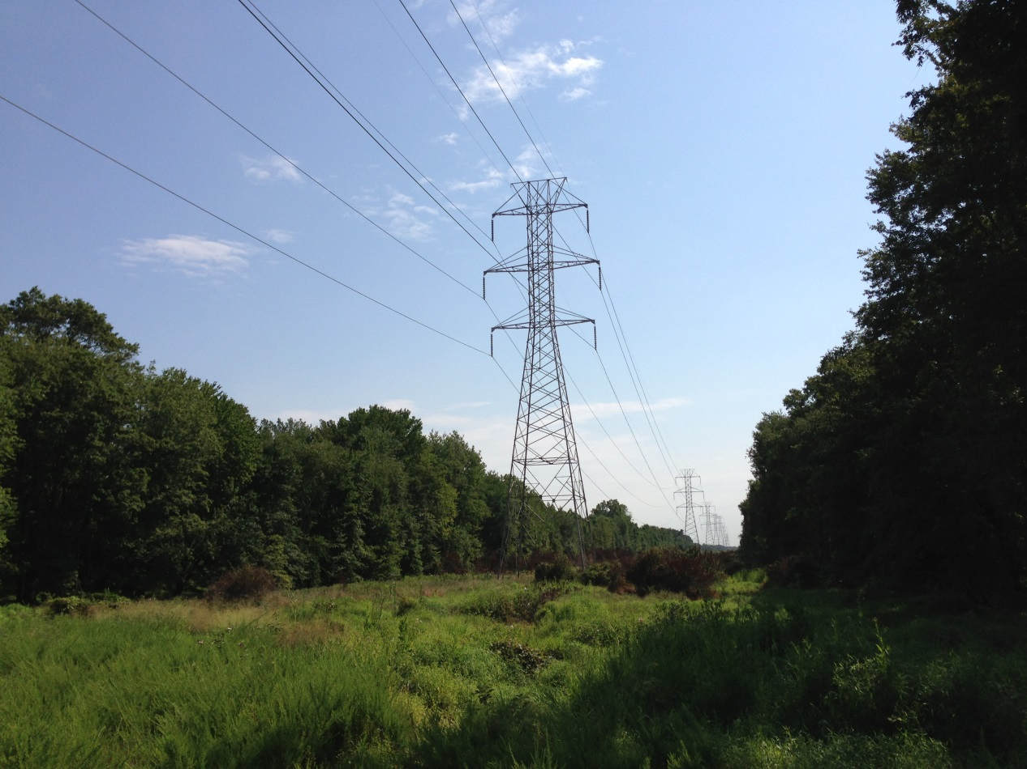

- Using Google Maps (satellite view), see if there are major high voltage electrical transmission lines nearby (pictured above). They transmit electricity long distances and can be seen on the satellite maps (they typically have all the trees cut down and no houses are located directly underneath them). I personally would not live within 1,000 feet of a major line (approximately ¼ mile). However, people who have not been injured could live much closer. There can be high magnetic and electric fields near these lines, which can be measured with the meters outlined in Section 3 of this book. You will ultimately want to verify that you are far enough away from the lines where your measurements with quality meters are negligible. There is also EMI radiating from these high voltage lines. A court case in Canada showed evidence that the harmonic frequencies on the lines harmed livestock. To protect your health, simply avoid living near these high voltage transmission lines.

  - A related item in Europe and Australia is electrified train lines that run through communities. These rail lines operate at the extremely-low-frequency of 16.7 Hertz and can cause health impacts for people who live within approximately 300 meters of the lines (approximately ¼ mile). I experienced first-hand the negative impacts of these powerful low-frequency exposures on a five-hour train ride in Austria in late 2015. It took me nearly two months to fully recover my health after this journey. Austrian health practitioners that I consulted said they often recommend that their patients move away from these electrified lines (Austrian holistic medical doctors are typically more understanding of the impact of man-made electromagnetic fields than practitioners in the rest of the world). Fortunately, you can use Google Maps to determine if a home is near an electrified train line and easily avoid these areas.

- You also don’t want to live next to a utility substation (where the higher voltage lines connect to the local distribution network). Electricity will return to this substation via the overhead electrical wires AND the ground (particularly in Wye served electrical distribution areas). If you live next to a substation, there is a high possibility that there is electrical current flowing through the ground that your house sits upon (such as aquifers and metal pipes). In some neighborhoods, this has caused immense health damage. Luckily, most neighborhoods do not have a substation. Here is an excellent expose ¹⁷ about what can happen to a community that has an electrical substation located next to homes. You can sometimes locate these using Google Maps. However, you may need to ask neighbors of a prospective home if they know whether a substation is nearby (see Phase Two).

- I encourage people who need a low-EMF home to live in protected valleys that are not densely populated (for example, large suburban lots in the East Bay Hills between Berkeley and Walnut Creek are ideal in the San Francisco Bay Area). Even a small valley along a hill will provide a lot of protection from most sources of RF pollution. Earth, reinforced concrete, salt water and vegetation can be good insulation from microwave radiation.

- Wealthier neighborhoods can have lower EMF pollution. I have seen this over and over again in the San Francisco Bay Area. It seems that wealthier/educated people can sometimes keep their neighborhoods free of antennas as they can readily afford the attorneys necessary for the political action and publicity needed to resist, or block, tower placement. The New York Times recently published an article ¹⁸ about how Palo Alto, the cradle of wireless technology and $2.5 Million average home prices, has terrible cellular service because so many residents don’t allow cell towers near their homes. In fact, Steve Jobs often could not get good cell service for his iPhone at his home. It can sometimes take just one committed property owner to stop a proposed cell tower in its tracks. As some studies show, ¹⁹ one cell tower can lower property values in a neighborhood by 20% (in addition to, or because of, the health effects), so there is good reason for their concern.

You want to use this to your advantage and either purchase the least expensive home in a wealthy area or rent an in-law unit/granny flat in a wealthy, less-densely populated neighborhood. I wrote the first draft of this guide from an in-law unit in an upscale area of Russian Hill in San Francisco. Even though this area is densely populated and San Francisco has high ambient RF levels, this property is built into the face of Russian Hill, directly above Fisherman’s Wharf. The hill provides excellent protection (and a beautiful view of the Bay and the island of Alcatraz), as does all the vegetation/trees in our backyard (the Parrots of Telegraph Hill visit us every day). The home is also surrounded by very expensive homes that are well-spaced and provide added protection. Plus, older homes in San Francisco have plaster walls with wire mesh inside, which acts to significantly reduce microwave radiation exposure (WiFi and cell towers are mostly blocked by the walls). San Francisco and some of the surrounding suburbs also have a Delta electrical distribution system, which is much healthier for residents. It is not often that I feel well in just any home, but this one is better than most I have tried the past five years. It shows that unless you are highly electrically sensitive, with a little luck you can even find a relatively healthy home in some urban and suburban communities.

  - A colleague used to work for a company that advises local governments on the regulation of wireless antennas. She noted that very few communities are ever able to block a cell tower on legal grounds (like a violation of local ordinances). This is because the Telecommunications Act (TCA) of 1996 supersedes almost all local laws. Instead, she saw the best success when communities came together to create the political will and publicity to convince the landlord to back out of a contract. She also noted that some wealthy neighborhoods will have even more antennas because there are often more subscribers and wireless devices in wealthier neighborhoods. Some wealthy families are also going all-in on the “Smart Home” with high-powered WiFi security systems. I can see this point, but also know many wealthy people who have educated themselves on this topic that will not allow a cell antenna near their expensive homes. It should be noted that wireless companies will often apply for facilities that they will not actually need. They do this because they can book a one million dollar asset on the company balance sheet simply by getting a new permit. This is quite a return on investment for the few thousand dollars the application process costs and may be part of why wireless companies are pushing so hard for new cell tower permits. It’s a wireless gold rush and directly affects telecommunication company stock prices.

  - I should also mention that cities, such as San Francisco and Boston, are currently (as of 2016) moving forward with a massive expansion of wireless antennas by placing the facilities on top of utility and light poles, as you can see in the images below. This is part of the coming 5G cellular rollout. As these poles are part of the utility right-of-way, there is no community process and no landowner to lobby. It is also difficult to protest these antennas because state laws favor the telecommunications companies on these installations. So far, just two out of more than eight hundred have been denied in San Francisco. Unfortunately, this means that many unsuspecting homeowners with a utility or light pole in front of their home could end up with a powerful antenna directly outside their home. Hopefully, with your help in raising awareness, your town will not follow San Francisco’s lead.

- Suburban or wealthy urban neighborhoods often have better quality electrical wiring. There have been improvements made because the local residents demand it from the utilities. These improvements can make the quality of the electricity better (less EMI – electromagnetic interference – conducted along the power lines and into your home). With the advent of the smart grid, I believe that newer home and electrical grid wiring is better able to handle the EMI created by smart meter pulses and all the other devices attached to the electrical grid. In rural areas – where the electrical grid equipment is older, substandard and not monitored regularly – I tend to experience electrical sensitivity problems much more often. Ironically, I feel better in parts of San Francisco than I do in a beautiful rural area like Occidental, California (1.5 hours north of San Francisco in Sonoma County). One would think a rural area like this is better, but my wife and I have experienced the opposite, likely because of the quality of the wiring and the EMI that is present.

  - A special note about this point: Bruce McCreary, a retired electrical engineer, mentioned that the difference in health between areas around San Francisco and the surrounding rural areas is partly due to the difference in electrical distribution systems. In San Francisco the utility uses the older Delta distribution system, which produces about 1/100th the ground current that Wye systems produce. All things being equal, electrically sensitive people feel much better in Delta served areas, so check with your utility to see what electrical system is used in your home search area. I encourage electrically sensitive people to seek out Delta served areas. Here is a thorough explanation ²⁰ by Bruce of the difference between Delta and Wye systems.

Populated areas can sometimes have less EMI conducted along the power lines because the utility is constantly monitoring the lines for sources such as powerline arcing and fixing errors. However, in rural areas, the only time the lines are monitored is typically during a power outage. Thus, if there is any loose metal on the power poles in rural areas, arcing may occur that will produce heavy EMI (dirty electricity) on the lines that will affect all homes within about 2 miles of the source. This EMI will actually drown out the entire AM radio band in severely affected rural homes. The EMI is also affecting your biology. The AM radio that I recommend later in the guide will help you determine if a home has this problem. I don’t usually recommend remote homes for several reasons, such as social isolation and inadequate access to health care. However, you can see that a Delta-served rural home could be the very best solution low-EMF solution for a severely EHS disabled person (aside from living completely off-grid with a DC solar system). This is especially true if you are far enough away from neighbors’ RF sources and you monitor the power line EMI with your AM radio and request that the utility fix any errors that arise. If you are interested in learning how to pinpoint sources of powerline arcing near your home, the best resource is the “AC Power Interference Handbook” by Marv Loftness. ²¹ Mr. Loftness was a true expert in this field and his knowledge on powerline arcing is essential if you choose to live in a rural area.

- Check Google Maps (satellite view) to see if there are solar panels installed on the top of your prospective home or a neighboring home. There can be health challenges with rooftop solar installations. Solar inverters, typically attached to the side of solar installed homes, change the DC electrical current generated by the solar panels to the AC electricity for the home and grid. The inverter creates high amounts of EMI that travel through the electrical wiring of a home and back to the unshielded solar panels and panel wiring. This EMI will then radiate into the living space around the panels and wiring. It also travels out to all homes (typically 5-10) that share the same transformer. This EMI can turn your home wiring into an antenna for these frequencies and I would encourage you to be cautious with solar technology unless you implement a DC system or until the solar industry solves the inverter EMI problem. Of all the projects that Elon Musk could take on, creating a healthy solar inverter may actually be the most important in the health of our planet and the health of humans.

- How old is the prospective home or neighborhood? Typically, the older a home, the more problems its electrical wiring will have. Some really old homes will have knob-and-tube wiring that must be completely replaced as it produces both high magnetic and electric fields. Even homes that are only 20-30 years old will have wiring that is not to the standards that I recommend (it is likely not shielded or installed properly). You can usually repair or replace the wiring (sometimes at considerable cost), but pay particular attention to this if you are renting where you have no control over this. There have been thousands (if not more) smart meter fires on older homes. The older wiring simply cannot handle the new devices – or shall I say, the cheaply made, plastic smart meters cannot handle older wiring. Note that I have stayed in an apartment in downtown Vienna, Austria (an area with high levels of ambient EMF/RF pollution) and slept well and felt good because the apartment was brand new (excellent wiring practices). The construction was also concrete, which appears to be much better for EMF reduction than wood. My measurement devices confirmed what my body was experiencing in this flat. All four types of electromagnetic fields were extremely low.

The following are pictures that will help you know what to look for as you find a healthy home:
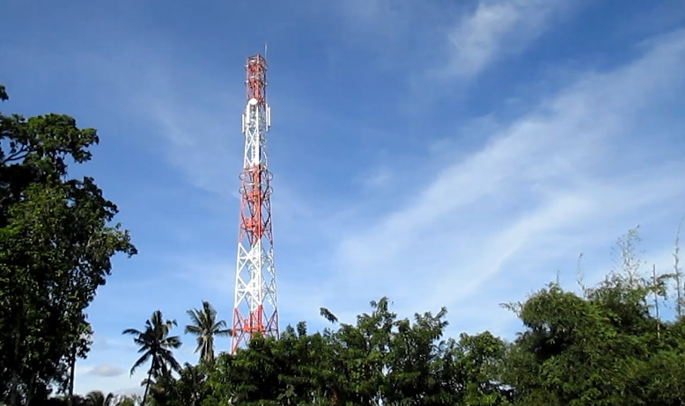
Not all cell towers are this obvious. This is one of the many cell towers sprouting up around Bali. The developing world is actually filled with cell towers, as they have bypassed the more expensive hard-wiring. Thus, moving to some tropical island is not as healthy as one would expect. The good thing about these areas is that they have older technology and usually lack wireless smart meters. However, I would expect them to catch up in the next five to ten years and these areas will be the last places to care about the health of citizens over the profits of monopolistic companies. Environmental rights and health movements in these countries are nearly non-existent.
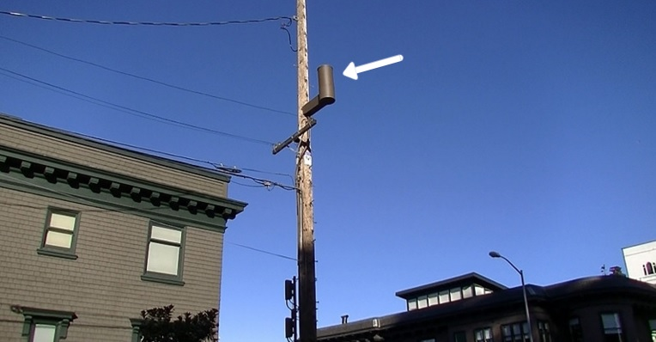
The arrow above is pointing to a new DAS (distributed antenna system) in San Francisco. Many residents are waking up to find one of these small, but high-powered antennas placed right in front of their home. A video showing how powerful these small antennas are can be seen here. ²²
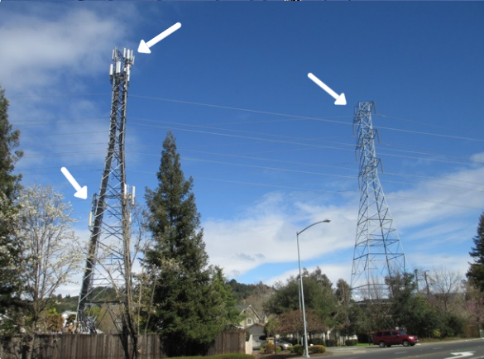
These homes near Santa Rosa, California have quite a few major issues. They are under high voltage transmission lines that also have cell phone transmitters (white boxes at top of left tower) and smart grid wireless infrastructure (white boxes half way up left tower). A perfect trifecta. This is a neighborhood that you could see from Google Maps is not one on which to waste your time.

The St. Ambrose Catholic Church in Berkeley, California is trying to get AT&T to put a new 4G cell tower in its steeple. Imagine going to a place to pray and feel peaceful, only to be agitated by a major cell tower right above you! The church will earn nearly $40,000 per year in rental fees, but an organized neighborhood has stopped them for now. ²³ Unless you have an RF meter, or have heard through the grapevine, you may not know a cell antenna is nearby until you felt the symptoms. As I mention above, I would no longer live near a church or school for this reason.

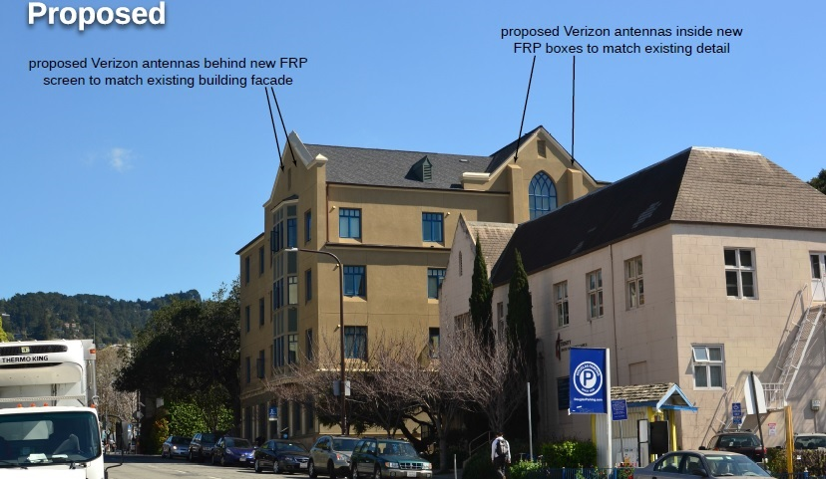
Image via: City of Berkeley ²⁴
If hiding a cell tower in a church steeple is not bad enough, now wireless companies are purposely remodeling the facades of buildings in order to hide the antennas. The above image is from a recent proposal to install a new 4G cell tower in Berkeley, California. EMF consultant Liz Menkes found from the engineer’s report that a person on the street below may be subject to exposures of 280,000 µW/m^2. Biologists who study this issue recommend maximum outside exposure levels of 1,000 µW/m^2. For EMF sensitized people, exposures over 100 µW/m^2 may cause symptoms within a short period of time. Many people who live near these types of towers may become electrically sensitive after several months or years of exposure. The increasing likelihood of a cell tower being hidden from view is why it is important for you to do your online research and to bring a good RF meter with you when you visit a property. It can take some detective work, but it is well worth it – especially with Verizon and AT&T implementing distributed 5G towers in 2017. With each new layer of wireless technology, the amount of people reporting electrical sensitivity increases, as does the number of people paying attention to this important issue.

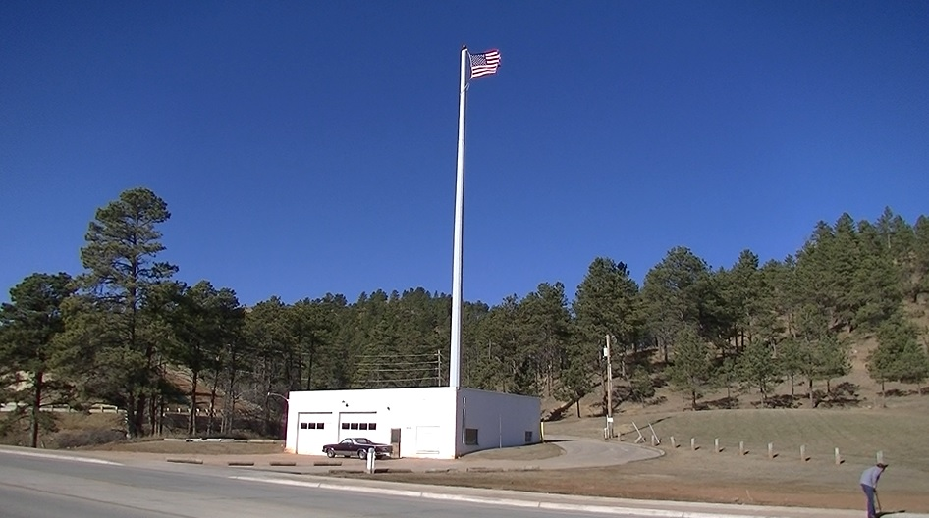
This may look like a patriotic display, but it is actually a new 4G cell tower. Having such a powerful tower in your neighborhood is not something I recommend. Unfortunately, most people never make the connection that this new flag pole is actually a high emitter of microwave radiation. The telecommunications companies have become increasingly creative in hiding this already invisible form of pollution from the public.

The Black Hills of South Dakota is a beautiful place filled with ponderosa pine trees. However, one of these trees certainly sticks out. This powerful cell tower is on a hill directly above very nice homes and residents who have no idea they are being exposed 24/7 to microwave radiation.
Phase Two – Initial Visit to Property:
This is the most important part. You can typically remediate the inside of your home once you purchase or rent it. However, if you have high sources of EMF pollution outside of your property, then even the most expensive remediation techniques may not make your home a healthy place to live. This is why it is so important to measure the surrounding area around your prospective new home.
Here is what to do when you arrive at a property:
- Get out and walk up and down the street. I mention below what meters you should have with you, but you want to initially check for microwave radiation and magnetic fields. There may be cell antennas or power lines overhead that you could not locate online. Take a good 30 minutes to walk around and see what is in the neighborhood. As you visit different homes, you will begin to realize that some neighborhoods are just better than others.

- With your magnetic field Gauss meter, walk down the street to see if a nearby power line or ground current is creating a field that is too high. Magnetic fields above 4 mG are the most dangerous (especially to children where leukemia is a risk) and multiple high quality studies ²⁵ back this up. I would like to the see the ambient field outside the home below 1.0 milliGauss (mG). Even better is below 0.1 mG (closer to what you would find in a more natural environment). If the field is above 1.0 mG, then you want to check to see if the field permeates into the home (more on this below). If this is the case, then I would walk away from this property, as you cannot adequately remediate this situation. Also realize that the magnetic fields from powerlines can fluctuate throughout the day. When there is more current flowing (say around 5:00 pm when everyone comes home or a summer afternoon when everyone’s air conditioner is running), the magnetic fields will be higher. In Wye electrical distribution areas, there will also be return current flowing through the ground (not just on the neutral wire). If a prospective property has high ambient magnetic field measurements, this could be the primary reason.

  - Even if the local powerlines in front of a prospective home look inconsequential, you still need to test for magnetic fields. I measured one home where a client had not been feeling well. A couple years prior, he had worked with an EMF consultant remotely who, for some odd reason, did not advise him to actually measure for magnetic fields with a basic gauss meter. When I turned on my Alpha Labs UHS2 gauss meter on their kitchen table, I was amazed to see readings of nearly 3 mG. When I walked outside and into the front lawn below the powerlines, the magnetic field readings were nearly 8 mG. In the home, the fields were between 3 and 4 mG, well above what we consider to be safe for long-term exposure. These large fields were likely due to some portion of the utility return current flowing through the ground of the property (aquifers and water/gas pipes), rather than completely on the utility neutral line. This created an imbalance of current flow on the powerline, which caused the large magnetic field throughout the property. Unfortunately for my client, this situation could only be mitigated through considerable expense and engineering work by the utility company. This is an expense they would not take on, nor a problem they can even admit exists (utility companies will say that magnetic fields up to 1,000 mG are safe). The only real long-term solution in this situation is to move and to make sure he measures for these fields before choosing his next home.

  - This brings up another consideration that will help you in finding a home with low magnetic fields. Homes that have plastic pipes (rather than only metal) connecting them to the water and gas mains will typically have lower magnetic fields. The plastic connectors will limit the utility return current from using your home’s pipes for the path of least resistance back to the substation. With less stray current flowing through your water and gas pipes, the lower ambient magnetic fields you will experience within a home. This is a great low-EMF technique if you are building or remodeling a home.

- Also check to see if there are any electrical transformers on the poles near the prospective home. These transformers do not necessarily emit high electric or magnetic field themselves (the fields diminish within 10-20 feet). However, because they step up the electrical current within the lines, they may create higher magnetic fields on the lines going away from the transformer. These magnetic fields may affect your home if you are on the wrong side of the transformer. You will need to check for this with your Gauss meter.

- With your RF meter, check to see if there are any major sources of microwave radiation nearby. Cellular companies in major cities like San Francisco have recently begun to put smaller cell phone and WiFi antennas on power poles. These are part of the Distributed Antenna System (DAS) and make it so that some homes now have antennas 10 feet outside their bedroom window (see pictures below). As I mention above, they rest right on top of utility poles and can be installed there with little public recourse because this is a “utility easement”. Obviously, if you find one of these nearby, you can move on to another property.

- Pay attention to high sources of RF emissions that are far away. Some powerful military/Doppler radar installations emit powerful signals that will be affecting residences up to 20 miles away. If you have a beautiful view of Mt. Tam in the Bay Area, then you are being exposed to pulses of microwave radiation from radar every 12 seconds. Mt. Diablo in the East Bay also has powerful radio and microwave transmitters. Homes higher on hills facing such mountains will have much higher RF levels. In fact, many of the $5 million to $10 million homes on the hills of Tiburon, California are exposed to high levels of RF from radio and cellular towers on the hills above Sausalito. In today’s world, living high on a hill with views of an urban/suburban area is usually not a healthy proposition. I know of multiple people who have gotten brain cancer living in such homes. These frequencies from powerful radio towers (from 90 MHz to 110 MHz) are not picked up by most consumer RF meters. You will want to utilize the Gigahertz Solutions HF59B mentioned in the meter section below or hire a professional to properly detect this form of RF pollution. Unfortunately, because of the lower frequency, these RF exposures are very difficult to shield if the power density levels are high enough.

- With your RF meter, check the neighboring homes for high sources of microwave radiation (cordless DECT phones, Comcast Xfinity or AT&T U-Verse Wi-Fi, wireless baby monitors, smart meters, etc.). With the right approach and education, most neighbors will decrease their emissions or move offending sources to the other side of their home. However, you don’t want to move in next to a Ham radio operator who has a powerful transmitter on their roof and will buy you a tin-foil hat for a housewarming gift! Ham radio operators have become increasingly rare. However, people have contacted me after becoming electrically sensitive from living next to one. It is simply best to avoid this situation if possible.

- Wireless smart meters, typically on the side of a home, are a particular problem. I advise that people do not spend a lot of time within about 30-40 feet of one – especially while sleeping. Every few seconds they are emitting high-intensity pulses of microwave radiation that are particularly bad for human biology. You can “opt-out” of your own smart meter in some localities by calling the utility. Ideally you can also encourage your new neighbors to do the same thing or to purchase a short-term solution such as a Smart Meter Guard. ²⁶ I encourage you to only use an electro-mechanical analog meter. Most electrical systems are made for these older style meters, so there will be less risk of fire. They are also far safer and there are no privacy issues. I have made videos of the various types of electrical meter systems, which you can view in this article. ²⁷

  - A note about wired smart meters: Although this type of system is rare in the United States, some utility districts have installed smart meters that transmit the data back to the main office over the power lines. This is called Power Line Carrier (PLC) or TWACS technology and is the predominant smart metering technology across Europe. This may seem preferable to wireless smart meters, but it can actually be much worse. The reason is that all copper electrical wiring now has these additional frequencies upon it. This purposely created EMI will radiate into the living environment of every home in these areas, essentially turning the home into an antenna. If you have the choice, try not to live in an area that uses PLC/TWACS technology. I know of EHS people who have had to move completely awy from these areas because there was nowhere for them to go. An excellent article on the health effects of PLC/TWACS smart meters can be found here. ²⁸ Wireless smart meters that you can opt-out of and shield your home from are preferred. Obviously, analog meters for you and your neighbors is the best option.

- Look for solar panels on the roof of the prospective home. As I mention above in Phase One, rooftop solar installations create EMI within a home and I would typically not recommend such a home. Solar may be perceived as an environmental savior, but it also creates unhealthy homes largely due to the power inverter and the EMI they create. By solving one problem (carbon reduction), we are inadvertently creating the next big problem (an electrical grid and homes polluted with EMI). You can see a picture of a solar inverter below.

- I encourage you to be bold. Don’t worry what people think when you pull out your EMF meters. Walk on people’s lawns (until they ask you to leave). Do whatever it takes to determine if this is the right neighborhood for you. Your health is your most important asset and you do not want to feel shy when it comes to this topic. It will also save you time and money by being upfront with this and your confidence will inspire interest! You may even find that some of your potential neighbors are friendly to this subject matter. If so, then you may have found your new home. A community that bands together on reducing artificial electromagnetic pollution is exactly where you want to live. I have made incredible friends walking down the street with my big green RF meter. Some people are scared of it, but the really interested (and interesting) people walk right up to me and start asking questions. I have made quite a few friends this way.

  - One important caveat to this point if you are in an extreme seller’s market: A reader explained to me how his realtor told him to NOT be obvious about measuring a home during the initial open house. He is in the San Francisco Bay Area and during the time he and his highly EHS wife were looking for a new home it was an extreme seller’s market with homes selling well above asking price within days to all-cash buyers (it has since slowed down in his favor). His realtor advised him that sellers were looking for the easiest offer to accept and if they even hinted that there could potentially be an EMF issue, their offer would never be accepted. To be more discreet, he would carry a small EMF meter in his pocket (like the Cornet ED88T meter mentioned later) to see if there were any obvious major magnetic or RF issues. He would then pull out his iPhone to see how many wireless networks were in the vicinity. If the home was appealing to them, they would then arrange to come back for a private viewing with more extensive measurements. If their offer was accepted, but the home proved to be un-mitigatable for their needs, they could gracefully back out. However, the offer had to first be “pending.” Talk to your real estate agent about this to navigate this delicate situation.

- If you can strike up a conversation with the neighbors (or the selling realtor), ask if they know what the health was of the people who lived previously in the home you are looking at. This is one of the most tell-tale signs of how healthy a home is. If the previous owners lived long, productive, healthy lives, then this home is likely a keeper. If they were often sick, always fighting, or if someone in the home experienced a serious illness, then you need to be very cautious about the home and really pay attention to the measurements that you will make in Phase Three.

The following images will help clarify the Phase Two steps for you. These pictures include many of the EMF sources you will encounter in your home search.
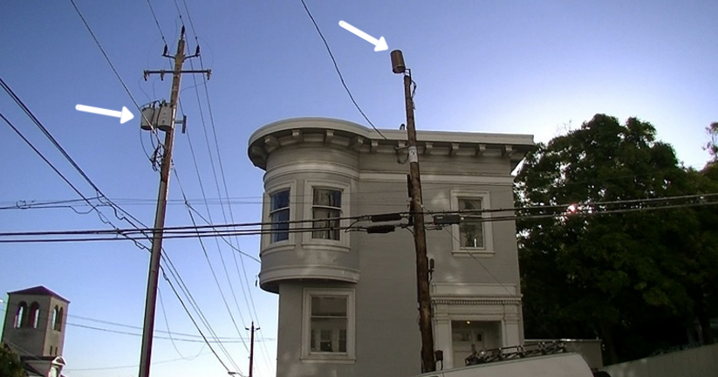
This home in the Russian Hill neighborhood of San Francisco is an example of a home to be very cautious about buying or renting. It has a DAS cellular antenna directly in front of the home (right utility pole) and electrical transformers next to the home (white boxes). There could be high magnetic fields emanating from the electrical lines in one direction away from the transformers. You will need to measure to know for sure. Additionally, older homes like this can have knob-and-tube wiring, which is very unhealthy. You will want to ask the realtor about this and measure the fields for yourself with all lighting turned on.
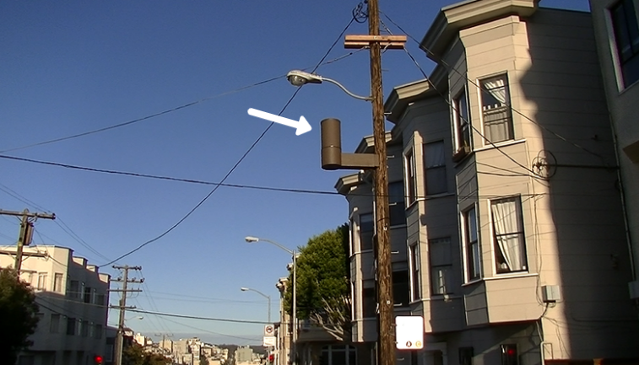
The cell antenna at the center of the above picture is likely quite dangerous for the residents of these homes. An engineer with the City of San Francisco told me that the exposure from one of these ExteNet antennas in an adjacent residence is approximately 1% – 2% of the FCC public limit (a limit that, as mentioned above, is not biologically based nor protective of human health). That means residents in the adjacent bedrooms are being exposed to nearly 200,000 µW/m^2 (microwatts per meter squared) of microwave radiation! Previously, I noted that you would not want to have exposures inside your home above 10 µW/m^2 (and much lower if you are electrically sensitive). These antennas will surely injure more unsuspecting people in the coming years.
These brown thimble antennas serve all four of the major carriers (Verizon, AT&T, Sprint and T-Mobile). However, for now, each carrier needs its own antenna (two carriers may share on antenna in the future). This means that some city blocks will have multiple cellular antennas next to homes. Unfortunately, in speaking with representatives of these wireless companies, these small antennas systems are scheduled to be placed in most urban and suburban communities in the coming years unless there is significant public backlash to this new potent form of electromagnetic pollution. Here is a video ²⁹ showing how much microwave radiation one of these antennas emits.

The dark box on the electrical pole above is an electrical transformer. These create magnetic and electric fields that can be measured 10-20 feet from the transformer. However, they also create higher magnetic fields along the lines going in one direction from the transformer (due to changes in current they produce). It is important to measure the ambient magnetic fields by walking below the lines that emanate from these transformers to see if they are abnormally elevated. As an example, I know of one family in San Francisco that bought a very expensive home in a popular neighborhood only to become ill six months later. It turns out the minor residential powerline next to their home was producing a magnetic field of nearly 10 mG throughout their entire home. Unless there was an easy fix for the utility company, moving is their only option.
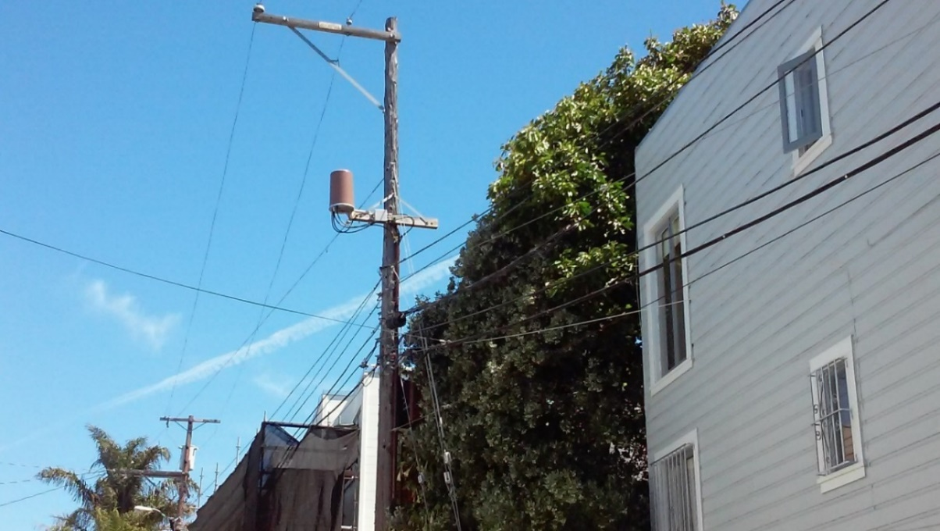
The above photo is DAS antenna in the Mission District of San Francisco (near Dolores Park). Someone’s bedroom is just 12 feet away (the regulations require at least 6 feet). These homeowners undoubtedly live with very high microwave exposures. There are now approximately 800 of these antennas in San Francisco. In some districts, multiple homes on each block have an antenna outside their front window. Communities all around the country are moving to install DAS antennas rather than installing high powered roof-top antennas (like the one directly below). The DAS antennas appear to have fewer regulatory hurdles to clear because they are placed upon existing utility or city infrastructure, rather than on a private dwelling. Fewer permits and less community interaction are needed (for now). The city planners also say there is little they can do because of the 1996 Telecommunications Act, which pre-empts local zoning authority. I made a short video that shows just how powerful this little antenna is, which you can watch here. ³⁰
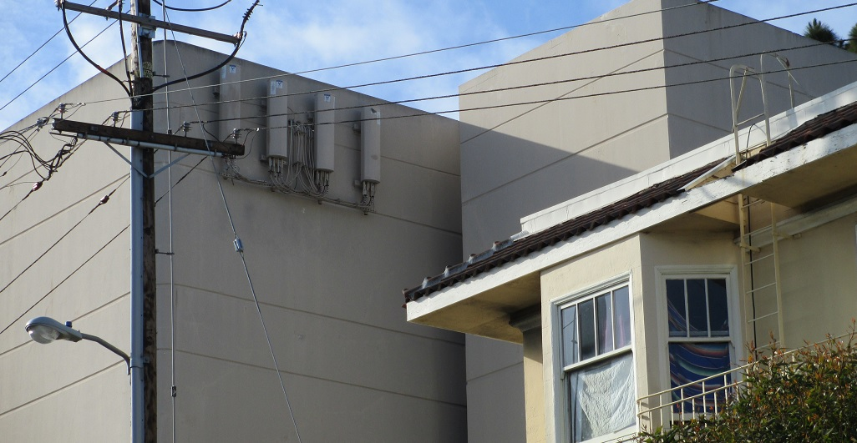
The above picture shows what a typical building mounted cell antenna looks like. As I mentioned above, most wireless companies are beginning to hide the antennas better, so they may not be this obvious in your neighborhood. Whoever lives in the apartment next to these antennas is being exposed to very high levels of microwave radiation. If you see one of these near a property you are interested in, it’s best to move on.
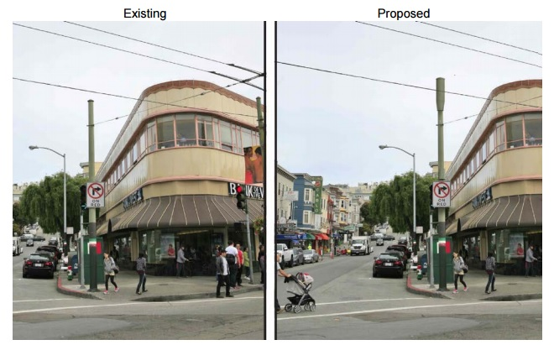
Image via: City of San Francisco ³¹
Cities such as San Francisco are now installing their own antennas on streetlights and lamp poles and leasing the bandwidth to wireless companies (Verizon is leasing most of the new grey antennas pictured above). San Francisco will install thousands of these antennas as the 5G network is created. You can learn more about their proposed plan here. ³² I encourage you to speak out about these programs in your community before the city government thinks this is a good idea.
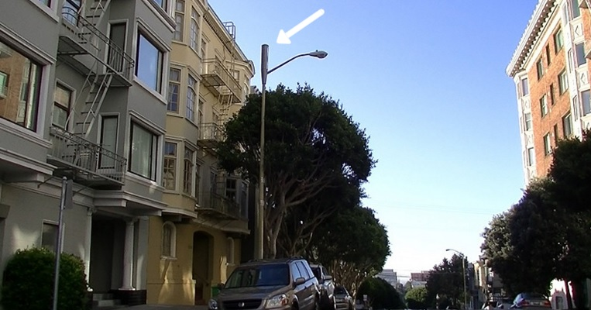
Above is a new antenna that has been installed by the City of San Francisco and Verizon. Note how close it is to the 2nd and 3rd floor apartments in the adjacent building. The microwave levels in these units are now much higher than anyone should be constantly exposed to. This street has an antenna like this installed on every block along its entire length.
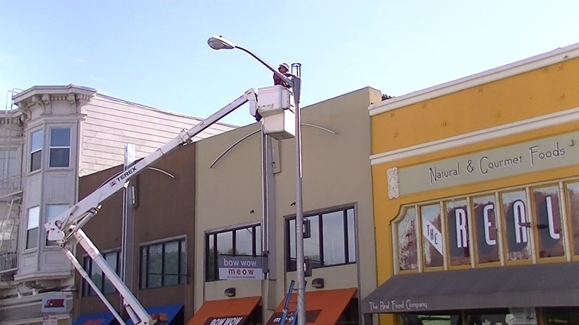
So many of these new Verizon antennas (pictured above) are currently being installed in San Francisco that I was able to take this picture of one crew in action. No notice was ever given to the neighbors in this community at Polk and Vallejo streets in Russian Hill. Communities are supposed to have official notices, such as this one, ³³ placed in public areas around the proposed installations. This is the neighborhood I first lived in when I moved to San Francisco fifteen years ago. The electromagnetic environment has changed dramatically since then with the installation of wireless smart meters, Xfinity WiFi systems, increasing numbers of solar inverters, ubiquitous smart phone use and now these distributed 4G / 5G cell phone antennas directly in front of homes. In a recent speech ³⁴ by FCC Chairman Thomas Wheeler, it was revealed that these new antennas are to be part of the coming 5G wireless build out for both Verizon and AT&T. They are beginning their pilot programs in 2017. The entire country and other carriers are set to go this route by 2020. 5G technology will mostly use millimeter wavelength (14 GHz – 100 GHz) ³⁵ frequencies that do not penetrate structures very well (3G and 4G technology primarily uses 1.8 GHz to 3 GHz carrier waves). 5G will also include 700 MHz frequencies for the “Internet of Things” and cellular communication which will allow for easier penetration into the home. In order for the super-fast 5G technology to work, companies must place many high powered antennas adjacent to homes (each antenna will serve approximately twelve homes). There is also a new development that will connect the towers to each other through wireless technology, rather than fiber optics. Connecting the towers to the network is called “back haul.” One Silicon Valley company has developed a 3.5 GHz wireless back haul technology that will greatly increase the amount of wireless radiation being emitted by 5G cellular antennas. Although this technology will give people faster download speeds on their iPhones and provide the necessary connectivity for autonomous cars, it will add much more microwave radiation to our communities than any wireless technology change to date.
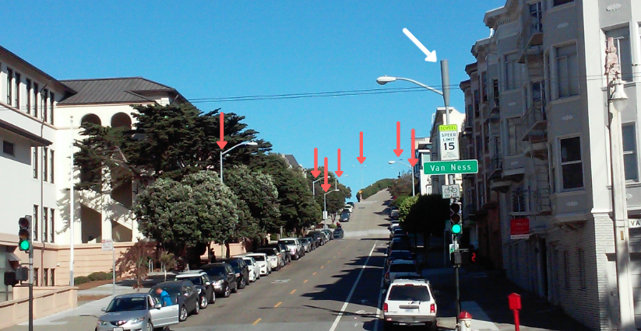
This is street near San Francisco’s Fisherman’s Wharf is a hypothetical image of what the 5G network may look like in major cities by 2020. The white arrow shows a 5G antenna that was recently installed by Verizon. The red arrows show the remaining light and utility poles that AT&T, Sprint and T-Mobile will utilize for their antennas. Most city blocks will have at least four powerful antennas located on utility poles, often right next to bedroom windows and schools (at left).
The building above has two issues that you can see right away. There are the two cell antennas above the window. Not only are the RF levels in this building likely to be high, there must be considerable electrical current feeding the cell antennas. This will create magnetic, electric and EMI fields in the home. Also, if you look closely in the upper left corner, the white boxes are extra WiFi antennas that a private company has installed. You don’t want either of these antennas located on, or pointed at, your home.
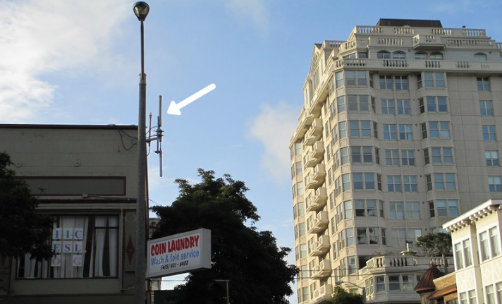
The little sticks to the right of the light pole above are Smart Grid relays. They are very powerful RF antennas that collect all the data from individual smart meters and send it back to the utility. With an RF meter, you can easily tell if one of these is near where you want to live.
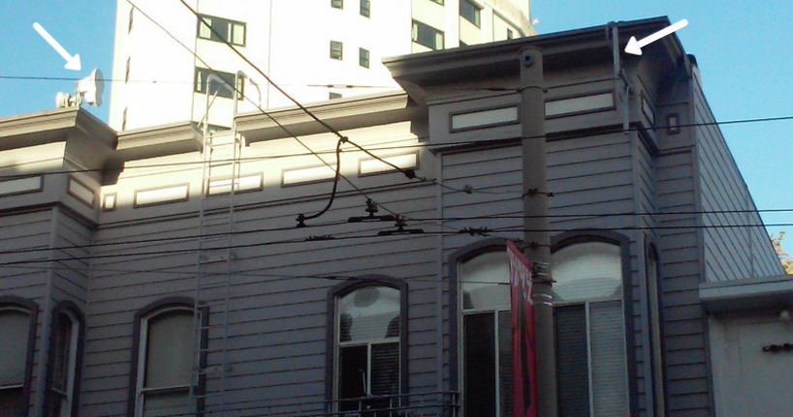
Last year my wife met a friend at a popular coffee place near the intersection of Fillmore and California Street in San Francisco. After an hour, she said she felt fried. I figured there was a major cell tower nearby, but upon further investigation found these small antennas on the building directly across the street from the coffee shop. The arrow at right points to what is most likely a smart meter repeater for the entire neighborhood. These incredibly powerful small antennas are located right on the wall of someone’s apartment and fill this street with RF. The arrow at left points out the antennas that are used to “back haul” the data to a location somewhere else in the city. Rather than using fiber optic cables, they are sending all data using wireless technology.
Public perception is that the overhead electrical lines seen in the photo above are the main form of electromagnetic pollution to be concerned about. This is typically false. The misperception is likely because the lines are something that people can actually see. As I mention above, there are indeed instances where these lines create high magnetic fields that can permeate into nearby housing. However, in most instances, the fields diminish within a few feet of the wires and are of little danger to the local residents. The only way to know for sure is to measure with your meters.

In the distance, you can see the infamous summer fog of San Francisco. The fog is such a fixture in the City that it has name (Karl) and has nearly 400,000 fans on social media. However, Karl is not the reason for sharing this photograph. Do you notice what’s different? Of course, the utilities are buried. Europe does this a lot more often than the United States (it can also cost 10X more to do this). Not only is this scenario more aesthetically appealing, it is usually better from an EMF perspective. The reason is that there is typically much less powerline arcing (a major cause of EMI in our homes). This is because the hardware is metal, so there won’t be wood shrinkage (a primary source of the arcing). The hardware is also protected from the elements, so there is not the corrosion of above ground powerlines, which can also cause arcing (as mentioned above, see the “AC Power Interference Handbook” by Marv Loftness ²¹ for more on powerline arcing).
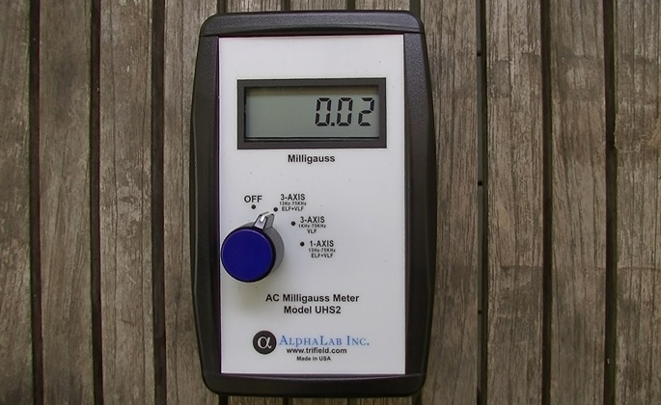
This type of underground power distribution system won’t reduce the magnetic fields if there is stray neutral current (due to the common utility practice of multi-point grounding of the neutral). However, the magnetic fields will be no worse than the aboveground lines in this case. In areas like San Francisco, which also have the preferred Delta power distribution system, this can be one of the best combination scenarios possible. This picture shows how low the magnetic field readings can be at my home in San Francisco – 0.02 mG.
If you don’t have a Delta system in your area, retired electrical engineer, Bruce McCreary, points out that a buried uni-grounded Wye distribution system is one of the best candidates for low-emission electricity distribution in a neighborhood. Not only will there be less powerline arcing, but the cables typically used for buried power are coaxial, with the high voltage wire in the center, surrounded by the neutral. This shields the high voltage electric field, which makes this a safer alternative.
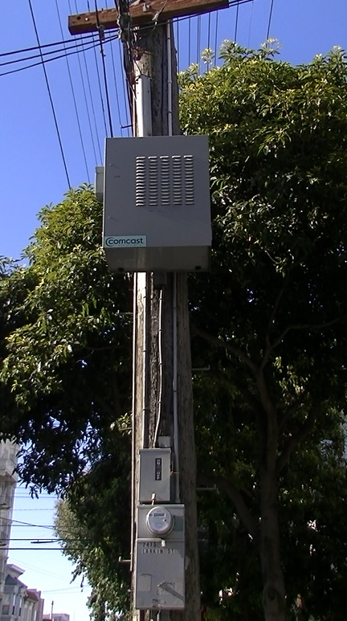
I share this picture because these boxes are going up everywhere where Comcast provides internet and cable service. This one is in Russian Hill in San Francisco. The boxes themselves are not a big issue – they appear to simply be relay devices for Comcast. I did not detect any RF being emitted from the boxes (the smart meter below each box does pulse similarly to every other smart meter). However, the issue with having Comcast in your neighborhood is that they are now using every home WiFi modem as a high-powered public hot spot for internet service. This means that if the neighborhood is densely populated, the microwave exposure of the residents will now be much higher.
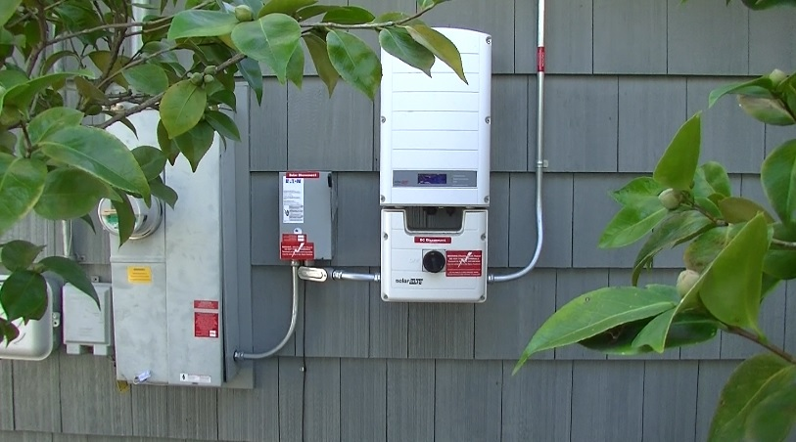
The above photo is what a solar system inverter looks like (at right). It is attached to solar panels on the roof and the wireless smart meter to the left. As I mention above, solar inverters create high amounts of EMI. Additionally, if you lease a solar system, the company will likely install a second smart meter. So, you will also have higher microwave radiation in your home. Ideally, your home and your adjacent neighbors do not have solar systems such as these.
Above is a picture of a restaurant in San Francisco that has an analog meter (left) and two smart meters (right). The safer analog meter has dials and a glass case around a metal core. The smart meters have a plastic, digital face. Unfortunately for the customers, this dining patio has five pulsing smart meters on it. Here is an article with videos ²⁸ that will help you identify the type of electrical meter on your home.
Phase Three – Measuring Inside the Home:
If a potential home has made it through Phase One and Two, then you are very close to crossing the finish line! Here is what you want to do during an open house or private viewing.
- Unless you are in an extreme seller’s market (as discussed above), pull out your meters. Knowing what is going on in the home is vitally important to your long-term health. It does not matter if you are renting a home for $500 per month or buying a home for $3.5 million, the electromagnetics are one of the most important (and overlooked) aspects of the home and you need to make sure the situation is right for you and your family.

- As I mention above, you are going to be checking the four types of EMFs in the home (magnetic, AC electric, microwave and electromagnetic interference (EMI)). I explain how to measure each of these in the next section.

- Initially, go around the house and check for RF sources within the home (Wi-Fi routers or cordless phones) that, oddly, might be on during an open house. Unplug these and any other transmitters you may find. Note that if there are a lot of people at the open house, then your RF meter will likely be picking up their cell phones. You can get around this by showing up early or later to the open house or arranging for a private showing. You will also learn how to distinguish between cell phones and more important RF sources as you become familiar with the meters.

- If every possible RF transmitter in the home is off (other than the smart meter, which you can’t turn off), see what your highest RF levels are. Whatever readings you are getting are coming from outside of the home. Are they within the safe limits outlined above? If not, are they something that can be shielded either with RF blocking paint, aluminum foil or shielding fabric? Be sure to make note of the RF measurements in the bedrooms. This is the most important area to have low levels.

- Now move on to magnetic fields. As I mention above, magnetic fields are the most important because they are likely the most damaging. Walk around the home to see what the ambient levels of magnetic fields are. Pay particular attention to what the readings are where you and your children will sleep and spend a lot of time. Are the readings within the limits outlined above with every light turned on and every appliance plugged in?

- Next, I want you to then find the circuit breaker box and turn the electricity off to the entire home (perhaps after warning the realtor that you are doing this). With the electricity off to the entire home, did your magnetic field readings go way down? Check in the bedrooms. Ideally, they will drop to below 0.1 mG. If they didn’t, that means that you have a magnetic field that is coming from outside the home (likely an electrical transmission line on the street or stray current that is flowing through the home or property). If it goes all the way down to below 0.1 mG, then you will have more control of the magnetic fields in your home.

- If the magnetic field readings dropped considerably with the electricity off, then you likely have a wiring error in the home that is causing a net current imbalance. The good news is that it is usually fixable with a little detective work and the help of a qualified electrician to make the repairs. In Appendix B, I mention Karl Riley’s book, “Tracing Magnetic Fields” ³⁶ and video. He explains what you and your electrician will be looking for and the potential solutions. Note that in some older homes where the wiring may be knob-and-tube or the wiring has been piecemealed together by many different electricians, you may be getting high magnetic field readings that can only be fixed by re-wiring the home. You will have to make the choice if the home is worth this added expense. Usually it’s best to move on.

  - I recently measured the home of a couple where the wife had not slept well in years. I found there was a high magnetic field (5 mG) right where the couple was sleeping. There were no other high exposures in the home. The magnetic field was coming from the wiring in the wall directly behind the bed headboard. So, we turned off the circuit, checked the wiring and found that one socket was wired incorrectly. The magnetic field disappeared and the wife has slept well ever since.

- The last two pieces are the 60 Hz AC electric fields and higher frequency EMI. Note that if you are going to re-wire parts of the home, then you have the opportunity to use shielded wiring practices that will greatly reduce the 60 Hz AC electric fields and EMI. A properly wired home (see Appendix B – Items 2 & 3) should have excellent electromagnetics.

- Now pull out your digital AC electric field meter or body voltage meter, which will detect the electric fields from unshielded (Romex) 60 Hz AC wiring. The most important places to check are the sleeping areas. You will need a proper ground (I recommend that you use a grounding stake with an extension wire to the Earth outside of the home). Then check what the readings are when you are where the bed is or will be. Generally, with the electrical breakers off, the measurements should be below 1.0 V/m or 100 milliVolts (mV) with body voltage. If the electric fields are over 5.0 V/m or 1,000 mV (1 Volt) with the electricity on, then your wiring is likely unshielded Romex. You can rewire the part of the house where you sleep with EMT conduit with compression fittings or MC Cable. A cheaper solution is to turn off the breakers where you sleep at night and/or use aluminum foil for electric field shielding (See Appendix B for additional EMF reduction suggestions).

- The final piece of measuring within the home is the electromagnetic interference (EMI) on the electrical wiring. One way to detect this is with a Radio Shack AM radio. The more static noise the AM radio makes, the higher amount of EMI that is present on the wiring of a home. High EMI homes will create loud static throughout the home. With the radio, you can detect specific sources or circuits within the home so that you can eliminate them. You can also measure EMI with a Line Noise EMI Meter. You simply plug the meter into the electrical outlets throughout the home to measure if there are major issues. If the home has dimmer switches, fluorescent lighting, switching power supplies, faulty wiring or a solar system inverter, then the reading can be quite high. Alternatively, the EMI could be coming from grid sources that are more difficult to remedy – such as a neighbor that has installed a grid-tied solar system or nearby powerline arcing. A digital AC electric field meter like the one I recommend later will also detect EMI in your home.

One note about the “filters” (they are actually capacitors) that are marketed to reduce EMI or “dirty electricity.” They are designed to lower the harmonics on the electric field component of your wiring within a certain frequency range (the range of their meter). However, they do nothing for EMI beyond this set frequency range and it appears that the harmonics are actually converted to the magnetic field component. ³⁷ Thus, you will likely be increasing the magnetic fields within your home and making the fields “dirtier” if you use these capacitors. Typically, these devices appear to help about a third of people, make no difference for a third and make the other third worse. I personally felt worse after using them and do not recommend these devices. If you do try them, get just a few to begin with, rather than spending a lot of money on something that may not work for you.

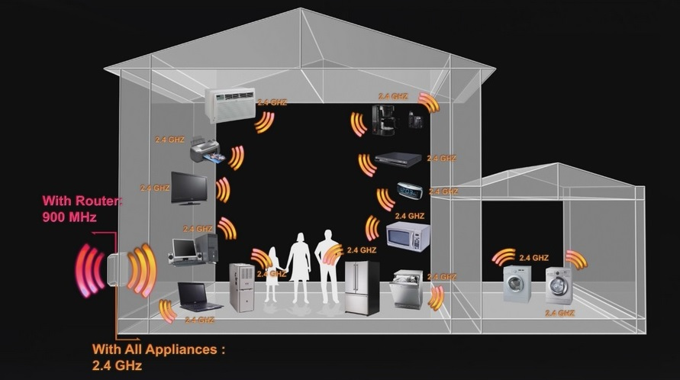
Image Credit: “Take Back Your Power” ³⁸
Some realtors may try to use the “Smart Home” artificial intelligence systems as a selling point. Do not fall for this. This means the home is filled with millions of pulses of microwave radiation each day (nearly every device and appliance will have an RF antenna). This technology was developed to detect things like cracks in oil pipelines traversing the Alaskan tundra or to help a shipyard or warehouse operate more efficiently. That is a great industrial use of wireless technology. However, it is not wise to put this in your bedroom, kitchen or on your body!
Test Driving Your Home
This suggestion may seem impractical – especially in hot property and rental markets such as the San Francisco Bay Area. However, I highly recommend that you spend a good amount of time at a home before you purchase or rent it. Your body will begin to tell you if this is the right home for you.
The ideal situation is that you are able to spend a night or two at the property. I can determine a lot by sleeping a couple nights in a home. My body can sometimes tell me what my meters did not catch (loads change throughout the day/night). I am thankful that I had this opportunity at several homes that my wife and I considered renting. The measurements with the meters were not perfect and after one night of trying out the home, my body let me know that the home simply would not work for us. We found entire areas (such as near Occidental, CA) that we ruled out after spending a couple nights in multiple homes there. We have also made the mistake of committing to homes that I knew after a couple nights would not work. After toughing it out for a month or two, I needed an equal amount of time to recover in a healthier location.
If you are considering buying your dream home or a piece of property where you will build your ideal home, I would find a way to spend as much time there as possible before signing a purchase or lease agreement. It doesn’t hurt to ask if this is possible. And, even if you only get to spend the 4 or 5 hours during the open house and walk-through while you measure everything thoroughly, this will give your body a chance to give you signs whether this is a healthy home for you.

Your Ideal Home
There is so much that goes into choosing the right home. There is the look, feel, construction quality, price, location, investment potential, school district, community and so much more. The EMF piece is just one aspect in a complicated decision. However, as I allude to above, the EMF piece is perhaps the most important aspect related to your health and it is something that you can control if you take the appropriate steps before purchasing a home.
I have outlined the detailed steps to take above. However, to simplify this process, here are the most important EMF aspects that you will see in an ideal healthy home. If you can make sure these are covered, then you will have found an excellent home.
- Magnetic field readings are below 1.0 mG with the electricity on and below 0.1 mG in your sleeping areas with the electrical breakers turned off. These low readings with the electricity off are particularly important in the bedrooms if you have someone in your family who is sensitive to EMF’s or has any type of chronic illness. If you get these low readings with the electricity off, this means you have no outside sources like nearby power lines, stray ground current or major wiring errors.

- Microwave radiation levels from nearby cell towers are low (less than 5 µW/m^2 for sensitive people and below 10 µW/m^2 for others in bedrooms). If the levels are higher, then you can always get an EMF Bed Canopy ³⁹ to sleep under that will bring the RF levels to well below 1 µW/m^2, which is what I recommend for anyone sensitive to EMF’s while they sleep. Canopies are often easier to implement than more permanent shielding paints and materials that you put on the walls.

- The home has good quality, shielded wiring that was properly installed (any of the common wiring errors have been fixed). If this is not the case, you could spend the money to rewire the home and use shielded wiring like EMT conduit or MC Cable. This will reduce the low frequency electric field and the EMI components within the home. If re-wiring the home is not practical, then turning off the circuit breakers to the sleeping areas will provide some benefit (see Appendix B, Item #6 for an important caveat). There will still be frequencies on the neutral/ground wires, but the EMI will be diminished overall with the breaker switched off. Laminated aluminum foil will also help to shield these remaining frequencies.

- You have found a good neighborhood with some neighbors that are aware of the dangers of EMF pollution. Ideally, the neighborhood has some natural protection like trees, vegetation, small hills/valleys and enough distance between homes so that a neighbor’s wireless technology and EMI sources are of little concern to you. Unfortunately, multi-unit buildings and tightly spaced suburban homes with neighbors who are heavy wireless users can no longer be considered a healthy place to live.

A home like this might be ideal, provided the EMF measurements you will learn about in the next section check out. What does your ideal home look like?
- The home is in a community where you can opt-out of the wireless smart meter program and you have neighbors who are also willing to opt-out, if asked. It is best not to sleep within about 50 feet of a wireless smart meter. I know of one woman in Santa Rosa, CA that got 150 of her neighbors to opt-out. This allowed her to continue living in her home and she now lives in a veritable EMF oasis!

- As mentioned above, the home is not already set up for the “Smart Home” systems. I have had clients who have become ill because of these systems. “Smart” appliances and TVs, speaker systems, wireless lighting systems and artificial intelligence personal assistance systems will increase the microwave exposure exponentially for families.

- The home does not have many items such as CFL and LED lighting, dimmer switches and wiring errors that can increase EMI on the wiring and magnetic fields within the home. Fortunately, much of this can be mitigated with a little detective work.

- There is not a solar system installed on the rooftop or on your neighbor’s rooftop (you will likely share the same electrical transformer and their EMI). Please contact me if you would like information on how to install solar with the least amount of EMF pollution and reduce the EMI caused by systems that have already been installed in your neighborhood. There is a lot of information available from Ham radio operators who have had to learn how to reduce solar system EMI so that their radio systems work properly. The frequencies that interfere with their radio systems also affect our biology.

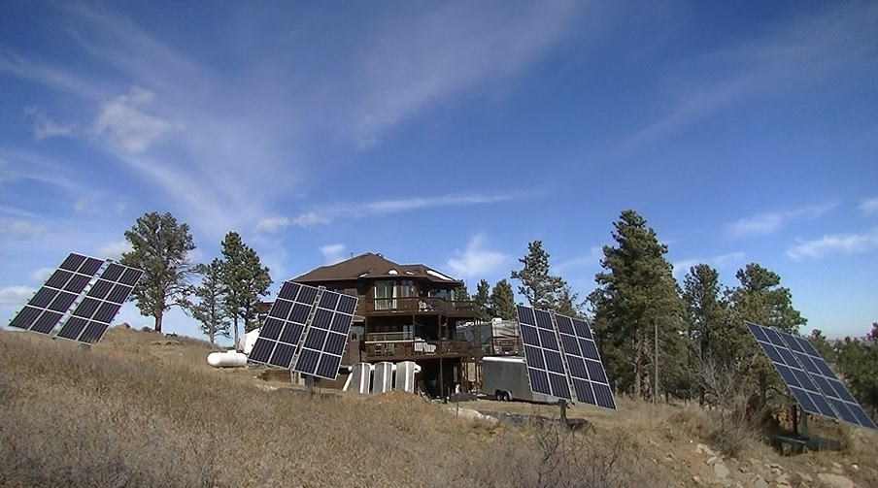
Installing solar panels in your yard can be a safer option than roof-top installation.
Solar technology has many environmental, economic and political benefits. However, there are considerable health costs if it is not installed properly. Unfortunately, most solar installers and consumers are not aware of the potential downsides. The inverter that converts the DC electricity generated by the solar panels to the AC that your home and the electrical grid uses creates a high amount of EMI or “harmonics.” These frequencies then conduct along the electrical wiring in your home and radiate into the living spaces. The EMI conducts back to the solar panels and the wiring attached to them. The panels and associated wiring are not shielded, so the inverter harmonics radiate directly into the area near the panels, the solar system wiring and at the inverter. These harmonics also travel along all electrical wiring in the home (and into neighboring homes as you can see in this video). ⁴⁰ Unfortunately, most inverters and panels are near living environments and can give homes a distinctive “buzz” that some people can feel. Everyone in the home is affected by this on a biological level, whether they feel it or not. The ideal situation is to have the panels and inverter away from the house or primary living areas (like the home above). There are also ways to reduce these harmonics with whole-house filters, but they can be expensive and difficult to implement correctly. I point toward methods to install solar technology more safely in this article. ⁴¹ If you are electrically sensitive or concerned about your long-term health, I would avoid AC solar systems until the EMI issue is recognized and solved by industry (a safer inverter may be possible, but too expensive for wide spread adoption at this time). I have already had dozens of families contact me who have been injured by these systems and in cases where they signed 20-year contracts with firms like SolarCity, there was nothing they could do – except pay a substantial cancellation fee or move. Some have chosen to move.
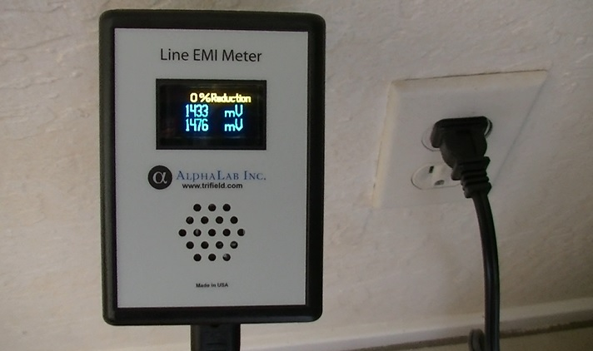
The above image shows the EMI being produced by an AC solar system inverter. Ideal readings are near 100 mV, with most suburban homes typically between 300 and 400 mV before any EMI mitigation is performed. Here is a video ⁴² showing how clean the power quality can be in a neighborhood with no solar power. Homes in communities with solar inverters sharing the same transformer typically have readings from 1,500 to 2,000 mV. In the following section, you will learn how to measure electromagnetic fields or find a qualified EMF professional near you.

Section 3
Measuring Electromagnetic Fields

How to Measure Electromagnetic Fields
Now that you know what you are looking for in a home (and what you want to avoid), I want to walk you through the process of measuring the different types of electromagnetic pollution. You will utilize this in Phases Two and Three above. There are three routes you can take to accomplish this, depending on your location, resources and technical ability:
- Hire an EMF Consultant to analyze potential home(s).
- Purchase a basic EMF meter package.
- Own an advanced EMF meter package that is very sensitive/accurate.
The following is what you can expect from each of these scenarios:

- Hire an EMF Consultant:
In a growing number of urban/suburban areas, there are EMF consultants that can measure your home for the four different types of EMF pollution. For a home assessment, the consultation will typically take 3-4 hours to be done correctly. However, based on the protocol outlined above, an experienced EMF consultant should be able to determine if the home has some major issues within an hour. I have shown potential homeowners deal breakers within 15 minutes. It saves them tens of thousands of dollars and lots of time in the long run.

Option 1: EMF consultants typically charge between $300 and $600 for in-person assessments, depending on the time spent, distance travelled and region of the country. The average is approximately $400 across the country, but can be up to $600 in more expensive areas like the San Francisco Bay Area. If you contact me I can recommend a professional that I trust in your area. Most will also be able to recommend a qualified electrician in case remediation is necessary to reduce the electromagnetic fields in your home. I can also recommend EMF professionals that can guide your electrician over the phone. A primarily advantage of hiring a professional EMF consultant is the quality of their meters, which are usually very accurate and highly sensitive and cost between $3,000 and $5,000 in total. They will also have some experience with shielding and remediation, so you can often learn a lot from a session with a consultant.

Option 2: Phone/Skype consulting can also be valuable if you live in an area without an EMF professional. This is particularly effective if you have a basic meter package that will give the EMF consultant a picture of what is going on in your home/potential home. I can also provide info on professionals offering Skype consultation upon request. Most EMF professionals charge between $100 and $150 per hour (prorated for actual minutes of the call). You can learn and accomplish a lot in a one hour call. This is a great way to speed up your learning process if you have questions after reading this book.

- Purchase a Basic EMF Meter Package:
I will now outline the basic EMF meter package that I recommend. The following are meters that will allow you to measure the four types of EMF pollution (magnetic, AC electric, microwave and EMI). This setup will also allow you to measure your own home while working with an EMF consultant on the phone to go over your measurements/findings. I consider this package to be a good start for most people. However, if your family has someone who is electrically sensitive and needs readings in the “sensitive safe” range, then I recommend the advanced meters that I outline in the next section or to hire an EMF consultant with professional meters. People who have been injured by EMFs need meters that are as sensitive as their body. Entry level meters will rarely accomplish this and can cause more harm than good. Every family with an electrically sensitive person should have a good EMF meter kit. This investment will benefit you for the rest of your life.
To save you time and money, I have provided links (in highlighted text and in Appendix D) to the lowest prices from reputable companies that I have found online (I own each of these meters myself). I receive a small affiliate commission for some of these meters if you make a purchase through the links provided below and on my website. This helps to make this educational work sustainable for me and I appreciate your support. However, my purpose is to give you the most accurate and current information possible, not to sell EMF meters.

Meter #1 – Cornet ED88T RF/Magnetic/Electric Field Meter ⁴³ - $171 (Use coupon code EMFA-10)
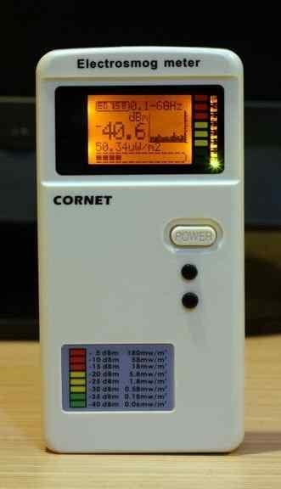
The Cornet ED88T is a good meter for this price. It measures microwave radiation (RF) and low frequency magnetic and electric fields (Tri-Mode). For RF, it has excellent sensitivity (to -60 dBm or 0.1 µW/m^2) and measures a wide range of frequencies. It is also easy to travel with. However, it is a single-axis meter. This means that it is not taking into consideration fields that are coming from every direction and may miss certain magnetic fields based on how you are holding the meter. This meter does a good job of showing you if you have bigger problems that need to be addressed. The meter has a sound component so you can hear the microwave radiation (a good way to make this real for other people) and can tell you what the actual RF frequency is. Here is an instructional video ⁴⁴ to help you use the Cornet meter, along with a video ⁴⁵ that shows the pros and cons of the ED88T meter. Another popular tri-mode meter is the Trifield 100XE ⁴⁶ for $110. However, I don’t recommend the Trifield meter because it is really only accurate for magnetic fields.
The Cornet ED88T ⁴⁷ (use this second link for a better price if you live outside North America) along with the Radio Shack AM radio (Meter #4) described below will give you a basic meter kit that will detect all four types of electromagnetic fields for under $200. This setup will not provide the sensitivity that I recommend or that you may need, but is a good way to get started if you don’t have the funds for the more sensitive and accurate meters described below.
Meter #2 – Body Voltage Meter with Grounding Chord and Stake ^{48, 49} - $109
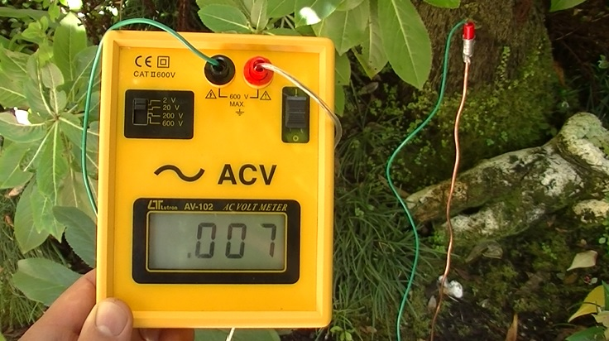
I almost did not include the body voltage meter in this guide because of how little respect this method has with electrical engineers. However, this guide is for beginners in EMFs and there is benefit for you to see how AC electric fields from unshielded (Romex) 60 Hz wiring couple with your body. By seeing this for yourself, you can then make decisions about how you want to mitigate the exposure from electrical wiring.
Electrical engineers typically do not respect this method because the typical body voltage meter has such a small frequency range (40 Hz to 500 Hz) that it basically misses all electric fields outside of the electricity frequency (50 or 60 Hz). It is also very easy to get false results if you use your home safety ground in the measurement (e.g. you plug it into your electrical socket). This is because most homes have several wiring errors that will make the results inaccurate. Another reason for the skepticism is that you can accomplish the same thing with a much cheaper digital multimeter, which you can purchase on ebay for less than $20. However, the digital multimeter route can be confusing for a beginner and you still need the proper grounding stake / extension wire pictured above.
The primary benefit of using the body voltage method is that you can plainly see how turning off certain circuit breakers or unplugging certain items will lower your exposure to 60 Hz AC electric fields. It will also show you how beneficial EMT conduit with compression fittings, MC Cable and aluminum foil shielding can be at reducing these electric fields. Reduction of 60 Hz electric fields where you and your family sleep is important and, for this reason, the body voltage method can be a worthwhile step in your learning process.
To use this meter properly, you need to utilize a grounding stake, rather than your home wiring system. I use a 2-foot copper wire pictured above that you can purchase at your local hardware store for $1.50. You will put this wire into the earth away from the house and buried electrical wiring. A 50-foot extension wire ⁴⁹ is necessary to connect the copper wire grounding stake to the body voltage meter (you may want to get two 50-foot extension wires to give you more room to move around). You will need to use the home wiring ground if you are several floors up in an apartment building. This won’t be as accurate and you must first test that the ground is properly wired. Engineer and EMF consultant Michael Neuert has a video that demonstrates the proper use of this meter, which you can watch here. ⁵⁰ To measure the higher frequency electric fields, which make up the bulk of the electric fields on home wiring, you will utilize the Line Noise EMI meter and AM radio described next, or the digital electric field meter described later on (Meter #7). A professional spectrum analyzer will ultimately provide the most accurate measurements.
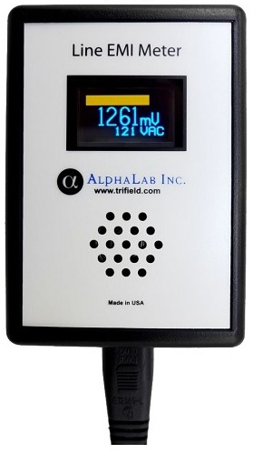
Meter #3 – Broadband Line Noise EMI Meter ⁵¹ - $159

The Line Noise EMI Meter measures the higher frequency electric fields on the electrical wiring of your home. This meter measures a wide range of frequencies and translates these frequencies into milliVolts (mV). It measures electrical line frequencies from 2 KHz to 10 MHz. I like this meter because it uses a common measurement unit (milliVolts) that is accepted by engineers everywhere (unlike the Stetzer dirty electricity meter). It also has a sound function, so you can actually hear the line noise. People who need “sensitive safe” EMI levels would want readings near 100 mV. Most suburban / urban homes have reading between 300 – 400 mV before any EMF mitigation and removal of EMI sources. In situations with solar inverters, readings can be between 1,500 and 2,000 mV, which is not healthy for most people.

Meter #4 – Radio Shack AM/FM Radio (Model 12-467) ⁵² - $10
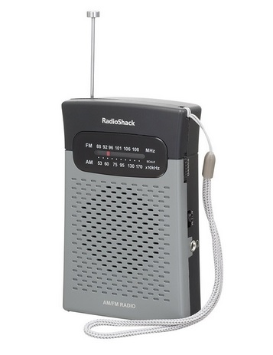
The right AM radio is an excellent EMI detector. You turn the dial all the way to the left (530 KHz) and the radio will show you a difference in static based on changes in the electromagnetic environment. This is especially good for detecting higher frequency electric fields (EMI) up to 2 MHz. Listen to the sound of the static outside the home (it should be relatively low). Then walk into the home. If you hear a noticeable change/increase in the static sound, then the prospective home has EMI issues. The radio will help you find specific sources of higher frequency electric fields in your home (dimmer switches, CFL and LED light bulbs, powerline arcing, or a solar system inverter). It will also help you see if EMI is present on your wiring even with the circuit breakers off (on the neutral/ground). Once you locate the sources, whether in your home or outside, you can then eliminate them. I specifically recommend the older Radio Shack AM/FM Model 12-467, ⁵² which can currently be found on ebay for $10. Most of the newer models, such as Radio Shack model 12-586, have been designed to not pick up the electric field static caused by many EMI sources. This makes the newer models useless for detecting EMI sources. Here is a video ⁵³ showing the AM radio in use.
The total price for the full basic package of four meters is $449, plus shipping/handling. Prices are accurate as of the publishing date of this book.
You can find these meters here: https://www.emfanalysis.com/meter-packages/ ⁵⁴

- Own an Advanced EMF Meter Package:
When it comes to finding or creating a home that is truly healthy for you and your family, I encourage you to invest in the best quality meters you can afford. If cost is an issue, you could even share the expense of the meters with other people in your community. As I mention above, I have seen over and over that it is best for people who are electrically sensitive to have access to good quality meters. This investment will protect your health throughout your life and will save you the money from constantly hiring EMF professionals. It will also help you better understand a subject that is vital to your long-term health.
Each of the following meters can be found at www.emfanalysis.com/meter-packages/. The prices below are current as of the publishing date of this book and do not include shipping/handling.

Advanced Meter Package #1 (using body voltage method):
- RF/Microwaves: Gigahertz Solutions HF35C ⁵⁵ - $312
- AC Magnetic Fields: Alpha Labs UHS2 3-Axis Gauss Meter ⁵⁶ - $299
- AC Electric Fields: Body Voltage Meter with Grounding Stake ^{48, 49} - $109
- EMI: Alpha Labs Line Noise Meter ⁵¹ - $159
- Higher Frequency EMI Detection: AM Radio ⁵² - $10
Total cost: $890

Advanced Meter Package #2 (using digital electric field meter):
- RF/Microwaves: Gigahertz Solutions HF35C ⁵⁵ - $312
- AC Magnetic & Electric Fields: Gigahertz Solutions ME 3851A ⁵⁷ - $356
- EMI: Alpha Labs Line Noise Meter ⁵¹ - $159
- Higher Frequency EMI Detection: AM Radio ⁵² - $10
Total cost: $840

Both of these packages provide accurate results for an electrically sensitive person. Professional grade meters will be even more sensitive. However, either of the above meter packages provide peace of mind without spending thousands of dollars.

Regarding Professional Meters: If you have a professional come to your home, they will often have a good quality spectrum analyzer, along with professional quality meters such as the Gigahertz Solutions NFA1000 ⁵⁸ for AC magnetic and electric field measurements and the Gigahertz Solutions HFE59B ⁵⁹ for a wide range RF/microwave radiation meter. These two Gigahertz Solutions meters cost approximately $3,700 together and will take some training to operate properly. However, if you have the financial resources and time to learn, they are two of the best EMF meters available to the public and allow for data logging that will help you see how your EMF exposure fluctuates throughout the day and night.
A Few Caveats on RF Meters: Unless you spend many thousands of dollars, no one RF meter is going to be perfect. All consumer RF meters have varying issues with sensitivity, frequency range and accuracy. In fact, this independent report ⁶⁰ commissioned by the German consumer protection agency (WILA Bonn) in 2016 showed just how inaccurate most popular consumer RF meters under $500 actually are.

If you can afford the more expensive Gigahertz Solutions meters and you are highly sensitive to microwave frequencies, I encourage you to purchase one from Safe Living Technologies (slt.co) in Canada. You can use my coupon code (EMFA-10) for a 10% discount on your meter. As you will see below, I recommend the Gigahertz Solutions HF59B for approximately $1,000 with the discount.

There are three popular RF meters that are affordable (under $400). The first is the Gigahertz Solutions HF35C (pictured below for $312). I explain below why this is my preferred RF meter for families who want a RF meter at a fair price. The second option is the Accoustimeter AM-10 ⁶¹ for $305 (use code EMFA-10). This is a good RF meter, but I find it is not sensitive enough for most electrically sensitive people and is not helpful in locating RF sources. Per the above German RF meter report, it is also not very accurate and registers very few frequencies above 2.7 GHz, even though it claims to measure up to 8 GHz. The third popular RF meter is the TES 593 from Taiwan ⁶², which is currently $370 on Amazon. This 3-axis RF meter claims to have greater sensitivity and frequency range than the other two meters. However, the German test report found that this meter was inaccurate, often over reporting or under reporting the actual power density levels. The TES 593 can also be difficult for beginners to understand and does not help users readily identify RF sources, which is one of the primary reasons to have a good RF meter in the first place.

None of the available consumer RF meters currently measure microwave frequencies above 10 GHz. 5G technology will primarily use frequencies from 14 GHz to 100 GHz (millimeter wavelengths). Gigahertz Solutions will likely create multiple RF meters to measure 5G frequencies as this technology becomes more widely adopted in our communities. Until that time, I recommend that you start with either the Gigahertz Solutions HF35C or HF59B seen below.

Meter #5 – Gigahertz Solutions HF35C RF Meter ⁵⁵ - $312 (Use coupon code EMFA-10)
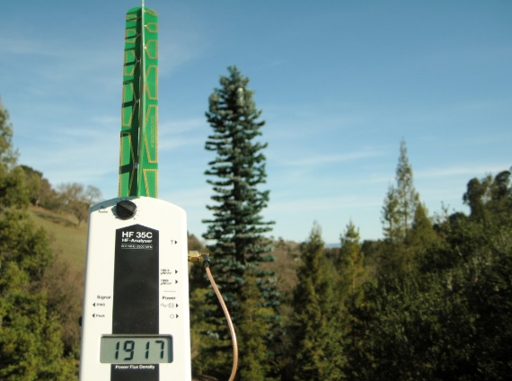
I like the Gigahertz Solutions HF35C RF meter because it easily helps determine the type of microwave source and where it is located. It provides power density readings from 0.1 to 1,999 µW/m^2. This meter is direction dependent (you can tell where the source is coming from) and it makes a different sound for each type of source (cell towers, WiFi, DECT cordless phones, Bluetooth, smart meters, baby monitors, etc.). This all comes in very handy in seeing what can be remedied and what cannot. The primary drawback to this meter is that it has a relatively narrow frequency range of 800 MHz to 2.5 GHz. This used to cover most of the commercial wireless frequencies. However, some WiFi and cordless phone systems now use the 5.0 to 6.0 GHz frequency range, so this meter will miss both the FM radio towers (around 100 MHz) and the higher frequency technologies. Here is a video ⁶³ to help you properly operate the user-friendly RF meter. If you were to upgrade from the HF35C meter, I would go to the Gigahertz Solutions HF59B, ⁶⁴ which sells for approximately $1,000 with the above coupon code. It is at least ten times more sensitive than the HF35C and has a RF power density range from 0.01 to 19,999 µW/m^2. You can add the omni-directional antenna for $400 (measures frequencies from 27 MHz to 3.3 GHz coming from all directions) that will allow you to detect nearby FM radio towers and gives you a much more accurate sense of the total RF exposure at a home or property.

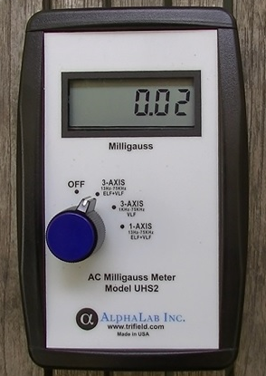
Meter #6 - Alpha Labs UHS2 Magnetic Field Meter ⁵⁶ - $299
The Alpha Labs UHS2 milligauss meter is one of the better magnetic field meters available in this price range. It is recommended for anyone who needs a very clean environment because it can detect AC magnetic fields down to 0.01 milliGauss. Ideal readings are below 0.1 mG. This meter also measures magnetic fields on all 3 axis and automatically calculates the correct reading. Most other consumer Gauss meters cannot do this. It also give you a choice of frequency range that is measured (ELF vs. VLF). This will allow you to determine if the magnetic fields are coming from 60 Hz electricity or a higher frequency. Here is a video ⁶⁵ demonstrating how to properly use this accurate Gauss meter.

Meter #7 – Gigahertz Solutions ME 3851A ⁵⁷ - $356 (Use coupon code EMFA-10)
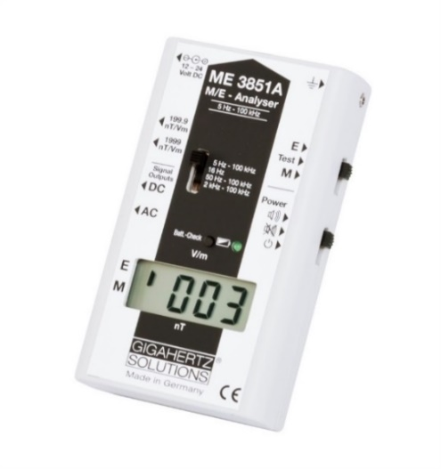
This high quality EMF meter allows you to measure both AC electric and magnetic fields, along with certain EMI frequencies. I recommend this model because it is much more sensitive and versatile than the basic Gigahertz Solutions ME3830B for only a modest increase in price. It also comes with a handy carrying case with room for your RF meter and grounding chord for better accuracy. This meter allows you to measure AC electric fields at a high sensitivity of 0.1 V/m from a frequency range of 5 Hz to 100,000 Hz (100 KHz). It has four different frequency range settings, with the higher range allowing you to determine if “dirty electricity” electric fields from solar inverters or CFL/LED lighting are radiating into your living environment. The AC magnetic field measurement is also very sensitive (to 0.001 mG). This is a single axis meter (unlike the Alpha Labs UHS2 above), so you will have to rotate it to make sure you don’t miss any fields. Here is a video ⁶⁶ to help you operate the Gigahertz Solutions ME 3851A meter.
Conclusion
You now have much of the knowledge necessary to find a healthy home from an EMF perspective. The following section will also give you specific steps to make your current home healthier or help you build a low-EMF home. I commend you for taking the time to understand this complex field. You are part of a pioneering movement of individuals and families that are realizing that vibrant health is dependent on reducing your man-made electromagnetic exposure. This guide represents the best of what I have learned through thousands of hours of trial and error the past five years. It also includes what I have learned from my mentors in this field, some of whom are the most experienced people in the country when it comes to understanding and remediating electromagnetic pollution.
The importance of this topic will only grow in the coming years as our society increases its dependence on wireless technology with the 5G rollout and the EMI on our electrical grid increases due to the expansion of solar technology. The truth is that our EMF environment will likely get worse before it gets better. However, do not despair. Just like smoking, DDT and asbestos were once everywhere and are now banned in most locations, our society will eventually wake up to the reality of EMF pollution and take the steps necessary to create safer environments and non-polluting technology. Until that time, you can do your best to find and create a home that is safe for you and your family so that you can live amazing, productive and healthy lives. This is entirely possible and my hope is that this guide has given you the skills to accomplish this with ease.
A healthy, vibrant home is possible by utilizing the steps provided in this guide.

Section 4
Creating a Low-EMF Home

Appendix A: Steps to Reduce EMF Exposures in Your Current Home

Thus far in this guide, you have developed a solid foundation in electromagnetic fields. You know what they are, how to measure them, what safe levels are and what an ideal home or property looks like if you are in the market to purchase or rent. However, what can you do in your current home to reduce your exposure? After all, most people love their home and community and simply want it to be healthier.
This section lays out the basic steps that you can take today to lower the electromagnetic pollution in your current home. I encourage you to have at least the basic EMF meters recommended above so that you can monitor your progress. However, many of the following steps will benefit you and your family even if you are not directly measuring the reduction in EMF pollution.
These steps are organized by the type of electromagnetic field pollution they produce: Microwave Radiation, Magnetic Fields, Electric Fields and EMI (dirty electricity).
Microwave Radiation (Wireless Technology):
- Move to wired internet. You can start by putting your WiFi router on a Christmas light timer so it is off when you sleep. However, this is really just a first step. I highly recommend that you don’t use WiFi in your home at all or only have it on for one or two hours each day when you need it. Be sure to turn off the WiFi in your home printer as well. Here are several articles from my website that give you simple, step-by-step instructions to have a wired home:

  - https://www.emfanalysis.com/the-basics/ ⁶⁷
  - https://www.emfanalysis.com/how-to-install-wired-internet-in-your-home/ ⁶⁸
  - https://www.emfanalysis.com/how-to-wire-an-ipad/ ⁶⁹

- Remove your cordless phones. This especially holds true if they radiate 24/7 (as many DECT cordless phones do). A simple corded phone near each phone jack is best. I really like this inexpensive AT&T speaker phone model ⁷⁰ for its simplicity and excellent sound quality.

- Use a safer baby monitor. DECT wireless baby monitors are often the highest emitters in a home. I explain a few alternative options in this article: https://www.emfanalysis.com/safe-baby-monitor/ ⁷¹

- Keep your older appliances or disable the “smart” functions in new items. Whether you have a new “smart” refrigerator, television or car, they have wireless antennas in them that will constantly pulse microwave radiation. I have felt ill around these new appliances after some hours of exposure (without knowing they were radiating). Smart appliances and the new artificial intelligence “home assistants” are simply not wise for your family in the long term and I advise that you avoid them. Here is an article that will show you how to disable many of these items: https://www.emfanalysis.com/how-to-disable-smart-appliances/ ⁷²

- Opt-out of the wireless “smart” meter program if you have one installed on your home. Some electrical and gas utility companies will do this if you demand it. Watch the film “Take Back Your Power” for more information on wireless smart meters and see this article if you are unsure if you have a smart meter: https://www.emfanalysis.com/do-you-have-a-smart-meter/ ⁷³

- Use your smart phone wisely. This is often your biggest source of microwave radiation exposure. Use speaker phone and an Airtube headset when talking. Also, turn off as many antennas as possible in your phone settings (such as WiFi, Bluetooth and Cellular Data) and utilize “Airplane Mode” often (it will stop radiating). Never put a phone on your body (pockets, under bra, near head) unless it is on Airplane mode. It is best to just use cell phones for occasional text messages and emergencies. I use a wired computer and wired home phone for everything else. I find this is better for both my physical and mental health to not always be connected. I have laid out my favorite tips for safer cell phone use here: https://www.emfanalysis.com/guide-to-safer-cell-phones ⁷⁴

- If a cellular tower/antenna is installed near your home or a neighbor installs a powerful WiFi router or wireless antenna, the simplest and most effective solution is often an EMF Bed Canopy. ⁷⁵ You could also utilize shielding paints and fabrics on bedroom walls, but a high-quality canopy is often the most versatile solution because it is not permanent.

Magnetic Fields:
- For low-frequency magnetic fields from 60 Hz electricity, you will need a gauss meter to see if you have problems in your home. With the gauss meter, you can find if there are particular areas in your home that have high magnetic fields (over 2.0 mG). You want to test this with all lights turned on and all appliances plugged in. The most common reason for such high magnetic fields is a simple wiring error made by your electrician. If neutral wires from separate circuits are improperly connected or if you have current flowing on metal pipes, there will be a current imbalance that causes elevated magnetic fields. The good thing is that this situation can often be easily fixed – typically with just an hour of time from your electrician or a handy friend who understands how electrical wiring works. See step #3 in Appendix B for further instructions on this process.

- If you measure elevated magnetic fields throughout your entire home, then it is possible that you have a major powerline nearby, high stray current from an adjacent utility company electricity distribution system or that your home has so many wiring problems or old wiring (such as knob-and-tube) that it needs to be completely replaced. Other than having a major cellular tower placed right next to your home, this situation is one of the only times where the best solution is usually to move. Fixing such a problem will either be incredibly difficult, prohibitively expensive or just plain impossible.
Electric Fields:
- Low Frequency electric fields from your 60 Hz electrical wiring can be a problem for people. Years of exposure to unshielded (Romex) wiring can wear down your health and cause sleep disturbances. Outside of re-wiring your home (see item #2 in Appendix B for more on this), you can reduce your exposure by turning off the circuits to your bedroom. There are very important safety caveats to this (see item #6 in Appendix B). However, by having your electrician install a contactor with a remote control switch, you can easily accomplish a significant reduction in your electric field exposures while you sleep. If turning off your breakers at night is not possible, then aluminum foil shielding can also be effective. Be sure to measure the reduction in electric fields with either your digital electric field meter or a body voltage/digital multi-meter mentioned earlier in Section 3 of this book.

- Higher frequency electric fields can also be present on your electrical wiring. This is typically what we refer to as electromagnetic interference (EMI) and is explained next.

EMI (Dirty Electricity):
- Higher frequency electric fields (EMI) will be present on your home wiring and can radiate into your living space if you have items such as dimmer switches, CFL bulbs, LED lighting, certain heating and air conditioning systems, and new electronic devices with switching mode power supplies (such as televisions, printers and laptop computers). One poorly designed appliance or the wrong lighting can send high amounts of EMI throughout an entire home. The good thing is that if the EMI is coming from within your own home (rather than a neighbor’s home or a polluted grid), then you can find the offending sources and fix or eliminate them. The easiest way to find this type of EMF pollution is with the AM radio mentioned in the EMF meter section above. You can also use the digital AC electric field meter and the Line Noise EMI meter to understand your overall EMI situation.

- Solar systems can produce high levels of EMI. The current design of grid-tied solar typically includes roof-mounted micro-inverters and MPPT voltage boost converters that produce a tremendous amount of EMI. I have already had dozens of families contact me with health problems after having a system installed on their home or a neighboring home. Almost all were unaware of this problem until after the fact. If you do go with solar, you will want to do professional filtering of the EMI to make your home healthier. With the right filtering of inverter harmonics and the proper engineering of the solar system, there are ways to make a solar system much safer for your family. Another option is the use DC (direct current) from the solar panels. This will also take some engineering for existing homes, but will alleviate the need for the inverter and the EMI it creates. DC solar systems with some filtering that use items like a Tesla battery pack could be a very healthy way for our society to move forward with solar technology. If you would like additional information on safer solar systems, please contact me as I am continually researching developments in this area.
Appendix B: Low-EMF Planning for a New Construction or Home Remodel

Rather than searching for an existing home, you may instead decide to build a new home or remodel a home that you purchase. This is an ideal time create a low-EMF home because there is so much you can do before the home is finished to ensure your health for decades to come. It is really a shame that the home building industry does not currently put these practices into place. For a modest increase in the price of materials, homes could be much healthier for the inhabitants.
The subject of low-EMF building and remodeling practices deserves its own book and the expertise of a highly qualified EMF professional and/or electrical engineer. An example of a professionally designed and built ultra-low-EMF home can be found here. ⁷⁶ However, I want to give you the basics so that you can consider these options if you are currently building or remodeling a home.
Here are ten basic low-EMF planning suggestions:
- Before building a new home, make sure the magnetic fields on the property are low enough for you. As explained previously, some neighborhoods will have significant ground current from multi-point grounding of the neutral. This will create magnetic fields that you can’t remedy. Check to see that the property you are going to build on has ambient magnetic fields well below 0.1 mG before you begin building. Some electrically sensitive people do best if the fields are below 0.01 mG. If not, it’s probably best to find a different property. If a home that you are going to remodel is already present, then turn off all electricity to the home to get your baseline magnetic field measurements for the property.

- Within your home, use shielded electrical wiring (not standard Romex) that will reduce the electrical fields (MC Cable or spiral aluminum clad wiring for instance). For even better EMF reduction for electrically hyper-sensitive people, use EMT conduit (electrical metallic tubing) with compression fittings and twisted wiring. This eliminates nearly all of the magnetic, electric and EMI frequencies. This is definitely the lowest-EMF option, but can be more labor intensive and thus more expensive to install.

- Double check the magnetic fields in a home as soon as the wiring has been completed by your electrician. There are often 2-3 wiring errors that can be easily fixed. The most common error is the white neutral wires from different circuits being inadvertently connected. This will create very high magnetic fields in rooms when one of those circuits is in use. See Karl Riley's book "Tracing Magnetic Fields" ⁷⁷ and have your electrician watch his informative video ⁷⁸. Karl notes that the second most important meter for this process (after your Gauss meter) is a quality clamp-on ammeter. ⁷⁹ This will allow you to measure and find the current differences on wires that are creating the magnetic fields. You should also check for current on metal pipes and other metal in a home. A certified plumber can fix this by adding a section of plastic pipe once a qualified electrician with an EMF mitigation background has found the errors. If you don’t have a qualified EMF professional in your area, contact me and I can put you in touch with someone to help you remotely.

- Avoid putting unnecessary electromagnetic interference (EMI) on the wiring of a home. This is often caused by dimmer switches, CFL and LED lighting, PLC/LAN technologies (using electrical copper wiring to transmit internet and smart meter data), and solar inverters. Homes that are healthy for the inhabitants will use incandescent lighting (which can still be purchased online) and will not utilize solar technology unless it is for a 120V DC electrical system or utilizes professional filtering. As described above, an AM Radio or Line Noise EMI Meter will show a builder the EMI coming from the grid or sources within the home.

- For a new home construction, you should consider putting most of the electrical and appliances in one section of the home. Putting appliances and items that you may react to in one corner of the home away from where you spend most of your time, and especially away from your bedrooms, is a wise thing to reduce your EMF exposure. Distance is your friend when it comes to EMF reduction. Distance is also the cheapest mitigation solution. Having a bedroom that is not even wired is often a great idea for electrically sensitive people. This is why the “Tiny Home” movement is likely not a good idea for an electrically sensitive person. Even though these homes can be taken to remote areas that may be more protected from radio frequency exposure, the tiny home is simply too small for a person to have a space in the home that is free of EMF exposure from the wiring and appliances. Adding solar to an off-grid Tiny Home is not a good idea unless it is DC solar without an inverter.

- If your bedroom is wired, most electrically sensitive people do much better with the electricity turned off at night. However, circuit breakers are not necessarily designed to be turned on and off every day for years on end. This could lead to them failing when a surge of current actually happens and could lead to an expensive repair bill or even a fire. It is very rare that a breaker will fail, but you should know the risks. To reduce this risk, you could install “switch duty rated” breakers (SWD) for your bedroom areas. These breakers are designed to act as a switch. You could also simply keep the breakers to your bedroom permanently off. I have done this in homes and kept a flashlight by the side of the bed.

- An even better long-term solution for the circuit breaker issue is to install contactors with remote switches to eliminate the repeated turning on and off of breakers. Not only does this eliminate the risk of breakers failing, the contactor will also separate the neutral in your bedroom from the grid. If you install triple pole contactors, the hot, neutral and ground wires will be completely disconnected. As Bruce McCreary explained to me, even if a circuit breaker is turned off, the neutral/ground are still connected to the grid unless you use a triple pole contactor. In a home or neighborhood with an EMI problem (which is most neighborhoods these days) the frequencies will continue to travel along the neutral/ground wire at night and disrupt your sleep and overall health. Safe Living Technologies (slt.co) in Toronto sells contactors with remote control switches ⁸⁰ that make it easy to turn off from your bed. You can use this 10% discount code (EMFA-10) if you want to purchase one of these to have your electrician install.

- Measure a home for outside microwave sources such as a nearby cellular or radio towers and neighbor's wireless transmitters. During the building or remodeling process, RF shielding material can be placed into certain walls if you don’t want to use bed canopies. Entire rooms can be shielded from microwave radiation with 1 mm thick laminated aluminum foil, mesh, paints and special shielding fabrics/materials. Window screen and film can also be used. RF reduction will help with sleep quality and overall health. I list recommended shielding materials here: https://www.emfanalysis.com/fabrics/. ⁸¹

- Any new home or remodel should include fiber optic lines or shielded Ethernet throughout the home. Many high-end homes in places like the San Francisco Bay Area are already doing this. A healthy future does not include WiFi in the home. At some point, if it's proven safe, LiFi may be used for some wireless applications (away from people). However, for a home, it is just not necessary when wired applications are readily available. Note that sending data over the home's wiring (PLC or LAN) is not a good idea. It exponentially increases the EMI on your copper electrical wiring. The same is true for some fiber optic products that have copper in them to conduct 5V of power (like HDMI), so you will have to do your research. Copper wiring (Ethernet) will radiate and transmit some EMI around your home unless you encase it in EMT conduit. This is why true fiber optics is much healthier than normal Ethernet. You can also use thin fiber optics on the outside of a wall (it is easily hidden and painted over). An Austrian company even has a technology that will replace existing copper wiring in walls with optical fiber. Several companies throughout the United States can install optical fiber for you. ^{82, 83}

- Unfortunately, the new "Smart Home" as currently proposed with a wireless smart meter, thermostat, speaker system, wireless TV’s and nearly every appliance or item in the house connected to the internet via a wireless antenna is not a good idea for home owners. There are also obvious privacy and security issues with these hackable systems that use artificial intelligence. However, I have already had families contact me who have become ill after installing such systems. They are wealthy, educated, early adopters of technology, who became ill within months of installing such systems because their homes had become filled with pulsed microwave radiation. They have had to disable these systems and some of them have had to move and sell their home. I sense this completely unnecessary layer of pulsed microwave radiation in homes, along with the implementation of 5G technology, will help to wake up more of society to this important issue.

A good book to read if you do plan on constructing or remodeling a healthy home is “Prescriptions for a Healthy House” ⁸⁴ by Paula Baker-Laporte and Dr. Erica Elliott. The book addresses some building materials and practices that can help people who have been injured by both chemicals and EMF exposures. It is a good place to start if you go down that road and will likely have additional helpful ideas for you.
Appendix C: Mini-Guide for Measuring a Property
(Available to download and print at www.emfanalysis.com/book-resources/)
Part A: Measurements of Neighborhood upon Arriving at Property
- Measure the magnetic fields as you walk along the road and around the house. You want the readings to be below 1 mG (closer to 0.1 mG for electrically sensitive people).
  - Your readings of magnetic fields outside the home = ________________________

- Measure the Microwave Radiation (RF) in the neighborhood. Ideally the measurements are below 100 µW/m^2 (10 µW/m^2 for sensitive safe) when you are outside the home. The following are the readings you want depending on the meter you are using.

  - Cornet Meter = 0.1000 milliWatts/m^2. Your readings = ___________________
  - Gigahertz Solutions = Below 10-100 µW/m^2. Your readings = _________________

Part B: Measurements within Home:
- Measure the magnetic fields in the home with the electricity on and off. Pay particular attention to field strength in sleeping areas. Fields below 0.1 milliGauss are ideal.
  - Magnetic fields with electricity on = Bed 1: ____________ Bed 2: _____________
  - Magnetic fields with electricity off = Bed 1: ____________ Bed 2: _____________

- Measure the Microwave Radiation (RF) in the home. Ideally the measurements are below 10-20 µW/m^2 in the bedrooms (for sensitive people, I recommend below 5 µW/m^2 in sleeping areas). The following are ideal readings depending on the meter you are using:

  - Cornet Meter = 0.0100 milliWatts per m^2. Your readings = __________________
  - Gigahertz Solutions HF35C = 5 µW/m^2. Your readings = ___________________

- Measure electric fields through body voltage or digital electric field meter. Ideal BV is below 1.0 Volt with electricity on and below 0.1 Volt with circuit breakers off. Ideal digital electric field is below 5.0 V/m (“sensitive safe” = below 1.0 V/m).
  - Electric Field with electricity on = Bed 1: _____________ Bed 2: ______________
  - Electric Field with electricity off = Bed 1: _____________ Bed 2: ______________

- Measure electrical line noise (EMI) in outlets throughout home. Here are the ideal measurement levels. Check to see if dimmer switches and CFL / LED lighting is used or if there is a solar system installed nearby. These will increase EMI readings and can typically be mitigated.
  - Line Noise EMI Meter – Ideal is below 400 mV: Your readings = _________________
  - Radio Shack AM Radio – Does the sound change when walking in and out of home? Can you locate high static areas in the home where EMI sources may be located?
Appendix D: Resources and Web Links

The following are resources and web links referenced throughout this guide. For your convenience, you can find these URLs online at: www.emfanalysis.com/book-resources/
As is the nature of the Internet, some of the following web links eventually disappear. This list will be kept current with correct links on my website at the above URL. Please contact me if any sources do not work or utilize Archive.org, which allows you to see webpages as they were in the past that have been removed from the web.
As an additional resource, I encourage you to visit my “Reading List” where I list the books and resources that have helped in my education on this subject. There are several excellent books on the EMF topic should you want to learn more. Visit: www.emfanalysis.com/reading-list/

Here are the references noted throughout this book:
- http://tinyurl.com/hzr7h2r
- http://tinyurl.com/hgo42cw
- http://www.bbc.com/news/technology-34075146
- http://tinyurl.com/j2z8wm6
- http://tinyurl.com/h9gcvsq
- https://www.emfanalysis.com/health-effects/
- http://www.sciencedirect.com/science/article/pii/S1382668915300594
- http://tinyurl.com/j744vms
- https://www.youtube.com/watch?v=W6SyJFPYM8c
- https://www.emfanalysis.com/what-is-dirty-electricity/
- https://www.emfanalysis.com/research/
- http://microwavenews.com/news-center/ntp-comet-assay
- http://ethics.harvard.edu/files/center-for-ethics/files/capturedagency_alster.pdf
- http://tinyurl.com/gv6mfkn
- http://www.antennasearch.com/
- https://www.emfanalysis.com/why-is-xfinity-wifi-harming-people/
- http://tinyurl.com/j2dmstk
- http://tinyurl.com/z6rt7g4
- https://www.emfanalysis.com/property-values/
- https://www.emfanalysis.com/delta
- http://tinyurl.com/je8ayql
- https://www.youtube.com/watch?v=oZfkYJnniP8
- https://www.emfanalysis.com/berkeley-church-cell-tower/
- http://tinyurl.com/htndurx
- http://tinyurl.com/jpv8geq
- https://www.emfanalysis.com/products/
- https://www.emfanalysis.com/do-you-have-a-smart-meter/
- http://www.eiwellspring.org/smartmeter/TWACS.htm
- https://www.youtube.com/watch?v=oZfkYJnniP8
- https://www.youtube.com/watch?v=l7-Ez4CN7PE
- http://tinyurl.com/gmddnpd
- http://tinyurl.com/nz46wvv
- http://tinyurl.com/gkuxele
- https://www.emfanalysis.com/fcc-on-5g-rollout/
- http://money.cnn.com/2015/12/04/technology/what-is-5g/
- http://tinyurl.com/j36lxmc
- https://www.youtube.com/watch?v=-M4j-YdyrVo
- http://takebackyourpower.net/
- http://www.emfanalysis.com/bed-canopies/
- https://www.youtube.com/watch?v=Rt9TrbImoQY
- https://www.emfanalysis.com/dark-side-of-solar/
- https://www.youtube.com/watch?v=c1wJ8JP0wqc
- http://slt.co/Products/RFDetectors/CornetED88T.aspx
- https://www.youtube.com/watch?v=tX1UKq8yFMI
- https://www.youtube.com/watch?v=zYKLBTDuZqo
- http://tinyurl.com/go7fw85
- http://www.radmeters.com/Cornet-ED88T-esh.html
- http://tinyurl.com/jzbb9t4
- http://tinyurl.com/zh9ra3n
- https://www.youtube.com/watch?v=q9jBJtruz9E
- http://tinyurl.com/hf9334a
- http://tinyurl.com/z7pfxzg
- https://www.youtube.com/watch?v=oNcfkPr8qY4
- https://www.emfanalysis.com/meter-packages/
- http://slt.co/Products/RFMeters/RFMeter-HF35C.aspx
- http://tinyurl.com/jhe5jk7
- http://slt.co/Products/EMFMeters/ME3851A.aspx
- http://slt.co/Products/EMFMeters/NFA1000.aspx
- http://slt.co/Products/RFMeters/RFMeter-HFE59B.aspx
- http://tinyurl.com/jmmvt5b
- http://slt.co/Products/RFMeters/AcoustimeterAM-10.aspx
- http://tinyurl.com/jnxphup
- https://www.youtube.com/watch?v=s99i0H-nBw4
- http://slt.co/Products/RFMeters/HF59BRFMeter.aspx
- https://www.youtube.com/watch?v=2wgggysXWQ0
- https://www.youtube.com/watch?v=fu_VETlvdSk
- https://www.emfanalysis.com/the-basics/
- https://www.emfanalysis.com/how-to-install-wired-internet-in-your-home/
- https://www.emfanalysis.com/how-to-wire-an-ipad/
- http://tinyurl.com/j8wmh3m
- https://www.emfanalysis.com/safe-baby-monitor/
- https://www.emfanalysis.com/how-to-disable-smart-appliances/
- https://www.emfanalysis.com/do-you-have-a-smart-meter/
- https://www.emfanalysis.com/guide-to-safer-cell-phones/
- http://www.emfanalysis.com/bed-canopies/
- http://www.eiwellspring.org/emc/HighlyShieldedHouse.htm
- http://tinyurl.com/j36lxmc
- https://www.youtube.com/watch?v=W6SyJFPYM8c
- http://tinyurl.com/zfkvfdr
- http://slt.co/Products/DemandSwitches/RemoteCutOffSwitch.aspx
- https://www.emfanalysis.com/fabrics/
- http://tinyurl.com/ha4pfmx
- http://lavishautomation.com/
- http://tinyurl.com/z3vfkc2

Acknowledgements
They say we teach best what we most need to learn. That is what this book and my website has been about. The process of teaching has led me to understand this topic much more deeply than I would have otherwise. I also realize that this journey is just beginning. My learning curve on this subject has been very steep, both out of necessity for the health of my wife and myself, but also because of incredibly knowledgeable people who have been my mentors the past few years.
First, I want to acknowledge Bruce McCreary for explaining the technical reasons why certain situations were more troublesome for my wife and I. You are likely one of the most knowledgeable electrical engineers in the country on this topic, partly because you have had to find ultra-low-EMF solutions for yourself. I sincerely appreciate your patience and the time you have spent trying to convey very technical concepts to someone who does not have an advanced degree in electrical engineering, nor decades of experience in this field. Where appropriate and applicable in this guide, I have tried to communicate some of what I have learned from you in a way that someone who is just beginning their journey with electromagnetic fields can comprehend. Hopefully my translation has kept the technical essence and allows for more people to directly benefit from your knowledge.
I also want to thank Richard Conrad Ph.D., Ron Powell Ph.D., K.T. Weaver and Cindy Sage. Each of you has been very generous with your time over the years in explaining some of the more complex scientific principles of electromagnetic fields and their effect on biology and our society. I am grateful for your efforts in keeping my writing clear and scientifically honest.
Michael Neuert, Liz Menkes, Stephen Scott, Emil DeToffol, Yair Freilich, Bryan Fromm and Rob Metzinger have always been available for my questions on meters and techniques to measure and remediate electromagnetic fields. Thank you for helping so many people around the world navigate this important and complex subject.
Dozens of people have reviewed this book and provided insightful feedback, stories and edits that have ultimately made it a better resource for everyone. I especially want to thank Dr. Mary Ann Iyer, Ashley McKay, Sandi Maurer, Dr. Gernot Neuwirth, Matthew Fisken, Melinda Zipin, Lisa Oh, Kate Corcoran and Joe Buller.
Thank you Christine Fasano for the initial encouragement to write this book nearly two years ago. As you pointed out, most electrically sensitive individuals and families need to find ways to live near schools, work and community so that their lives are not completely disrupted. I hope this guide will help the increasing number of affected individuals more easily navigate this process.
Finally, I am grateful for our family and friends on multiple continents who have supported us so much on this journey. Most people are not yet willing or able to accept the importance of this topic. I am fortunate to have people close to me who have the wisdom to begin to accept this new paradigm in human health.

About the Author
Jeromy Johnson helps people mitigate the negative impacts of Electromagnetic Field (EMF) exposure. He has a leading website on the topic (www.emfanalysis.com) and works with individuals, families and organizations around the world to implement solutions that reduce and eliminate EMF pollution. He has demonstrated that simple changes in our daily practices can go a long way to ensuring a healthier life.
Jeromy has an advanced degree in Civil Engineering and has worked in Silicon Valley for 15 years. He became what medical doctors call electrically sensitive (ES) in 2011 after being injured by extensive exposure to EMF radiation. Through the process of improving his own health, Jeromy immersed in the available data on the impacts of EMF exposure, personally vetted many of the possible solutions, and created a user-friendly presentation which he has delivered throughout the world to inform others about how they may protect themselves. You can watch his TEDx talk titled “Wireless Wake-up Call” online.

